* 1. **INTRODUCTION**

India has to support 1/6th of the world’s population, with only 1/25th of the world’s water sources with meager 1/50thof global land area. Deteriorating quality of surface and ground water is affecting the net availability of water for consumptive uses. Water pollution is a major environmental concern in India. Deteriorating water quality has become a serious problem. Safe water supply and environmental sanitation are vital for protecting the environment, improving health and alleviating poverty. Water of poor quality leads to ill health, whereas water in insufficient quantity claims large chunks of time spent in augmenting the supply; otherwise, the significant time could be spent on more remunerative tasks. Availability of water is bound to improve sanitation, safe hygiene practices and better health standards to make India a safer place for all its citizens. The need of accelerated water storage development, water conservation through reuse, wastewater recycling, aquifer recharging and effective rainwater harvesting as well as role of society; while focusing on the concerns and management of water quality related aspects in India.

Stress on water resources is from multiple sources and the impacts can take diverse forms. The growth of urban megalopolises, increased industrial activity and dependence of the agricultural sector on chemicals and fertilizers has led to the over loading of the carrying capacity of our water bodies to assimilate and decompose wastes. Owing to the indiscriminate discharge of untreated sewage and industrial effluents into natural water bodies, the quality of surface water as well as ground water is deteriorating. To meet the increase in water requirements in the country in the next 25 years, it would be necessary to ensure substantial augmentation of water supplies; requiring the sufficient raising of water storage capacities, thus necessitating the completion of new large water storage projects. According to the World Bank’s estimation water pollution accounts for about 60% of major annual environmental costs in India. Discharge of untreated domestic waste water is predominant source of pollution of aquatic resources in India. Urban centers contribute more than 25% of the sewage generation in the country. The smaller towns and rural areas do not contribute significant amounts of sewage due to low per capita water supply. The waste water generated in these areas normally percolates in the soil or evaporates. Owing to the indiscriminate discharge of untreated sewage and industrial effluents into natural water bodies, the quality of surface water as well as ground water is deteriorating. A result of this is that the principal drinking water supply sources of cities and towns are becoming polluted of which is increasing considerably the cost of water treatment. Major water polluting industries are leather, sugar, distilleries, paper.

**BACKGROUND:-**

Problem introduction or problem starting is the starting point of the software development activity. The objective of this statement is to answer: Exactly what must the system do? The software project is initiated by the client’s need. In the beginning, these needs are on the minds of various people in the client’s organization. The analyst has to identify the requirements by talking to the people and understanding to their needs. It goes without saying that an accurate and through understanding of software requirement are essentials to the success of software development effort. All further development like system analysis. System design and coding depends on how accurately the requirements are understood if they are poorly analyzed the specified software will disappoint the user and will bring brief to the developer. No matter how well designed and well appearances. Chances of misinterpretation are very high, ambiguity is probable and communication gap between customer and developer is bound to bring confusions. Requirements understanding begin with a clear and concise heading stating in sentence the task to be performed. Then requirements are describe in a technical manner precise statement.

* 1. **OBJECTIVE:-**

Today’s world is computer world because most of work is getting done with the help of computer. Dependency on computer is behind the few reasons. We cannot easily manage to store large number of data or information on paper. If we will be need some information or data in urgency then we cannot manage in manually these works are very difficult if we cannot use computer. Water supply is the one of the basic needs that each and every citizen of the country requires and is essential for the survival of the human beings. The person needs to pay the bill for the water that the people have used and pay for it. Sometimes there will be a long queue that one needs to wait in order to get the water supply bills paid. The Aqua Control will help the local government and the private institutions to manage the water supply system in a better way. It will also help the billing and invoicing to work in a better way.

* The main objective is to automate non computer environment
* To save manpower.
* It will speed the processing of data and transaction.
* It will provide best security features such as provisions of passwords.
* **SYSTEM CONTEXT:-** This section clearly depicts the environment and boundaries of the Aqua Control and the entities with which it interacts. It helps us to see how the system fits into the existing scheme of things. What the system will do by itself.
* **FUNCTIONAL REQUIREMENT:-**  This Software must request Username and Password for access to data, only after authentication access will be allowed to the system. The Software must allow input of products data from administrator and secured access.
* **NON-FUNCTIONAL REQUIREMENT:-** In this Software Input errors will be returned with appropriate message box. System should automatically update after every transaction.

**PURPOSE:-**

1. The purpose of this document is to specify requirements and to give guidelines for the development of above said project. In particular it gives guidelines on how to prepare the above said project.
2. This document is intended to be a practical guide for people who developing this software.
3. The database of the people who use the water supply must be organized in a good manner.
4. The facility of paying the water supply through online mode must be enabled to enjoy better payment facilities.
5. Reminders can be sent to the people whose water supply bills are pending for months or years together.
6. The Aqua Control will help to gain transparency between the government and the people of the city.
7. The people can have a look at the status of their bills at anytime from anywhere in the world.
8. The Aqua Control will help in the smooth functioning and managing of the water supply system in the city very well.
9. Sometimes people will not remember of the payment of the water supply bills. At that time through this system they will be to make online payment of the bills without any worry.
10. This software can be used by a wide variety of users and suppliers to automate the process of manually maintaining the records related to the subject of maintaining the product and cash flows.

**SCOPE:-**

Water management can be practiced in ways lie river basin monitoring to the household water usage monitoring. According to a survey, the water demand had risen by 6 times than the past from 1930 onwards while the population had risen only 3 times since then. This clearly means that the demand is way too higher in context. This water demand can go through the private swimming pools, rain dance parties, using drinking water for the daily bathroom chores, using the drinking water for washing vehicles regularly, etc. The curbing of such practices for not using drinking water scrupulously will benefit us a lot. The cities in our country have less population as compared to the villages in total but the water demand is way too higher in the cities than the villages and towns. So much so that a few places observe drought quite frequently. The Aqua Control thus starts from every individual and so it surely has a very large scope in India.

The definition of our problem lies in manual system and a fully automated system.

1. **MANUAL SYSTEM:-**

The system is very time consuming and lazy. This system is more prone to error and sometimes the approach to various problems is unstructured.

1. **TECHNICAL SYSTEM:-**

With the advent of latest technology if we do not update our system then our business result in losses gradually with time. The technical system contains the tools of latest trend i.e. computers, printers, FAX, Internet etc the system with the technology are very fast, accurate, user friendly and reliable.

1. **NEED OF AQUACONTROL:-**

* To provide an optimal solution to the water supply and garbage collector supply.
* Maintaining the water supply.
* Water supply for specific period of time.
* To reduce unnecessary waste of water.
* To produce a Social Awareness About water saving Activity.

1. **THE PROPOSED SYSTEM:-**

The proposed system helps them in many ways. It helps users to do billing very easily. Account maintenance also becomes easier. It can keep track of their supply,amount of water and account details. The software is provided with all the master entries to enter any type of water, or supplier, or customer to add or modify and delete.

1. **EXISTING SYSTEM:-**

An existing system is weak in maintaining the quality of water and not good enough in calculating that how much water is needed and in which area. It is also not good enough in maintaining the billing process and status of customers.

**3. SURVEY OF TECHNOLOGIES**

**FRONTEND TECHNOLOGY:-**

* **JAVAX.SWING:-** Swing is a [GUI](https://en.wikipedia.org/wiki/Graphical_user_interface) [widget toolkit](https://en.wikipedia.org/wiki/Widget_toolkit) for [Java](https://en.wikipedia.org/wiki/Java_(programming_language)). It is part of [Oracle](https://en.wikipedia.org/wiki/Oracle_Corporation)'s [Java Foundation Classes](https://en.wikipedia.org/wiki/Java_Foundation_Classes) (JFC);an [API](https://en.wikipedia.org/wiki/Application_programming_interface) for providing a [graphical user interface](https://en.wikipedia.org/wiki/Graphical_user_interface) (GUI) for Java programs. Swing was developed to provide a more sophisticated set of GUI [components](https://en.wikipedia.org/wiki/Software_component) than the earlier [Abstract Window Toolkit (AWT)](https://en.wikipedia.org/wiki/Abstract_Window_Toolkit). Swing provides a [look and feel](https://en.wikipedia.org/wiki/Look_and_feel) that emulates the look and feel of several platforms, and also supports a [pluggable look and feel](https://en.wikipedia.org/wiki/Pluggable_look_and_feel) that allows applications to have a look and feel unrelated to the underlying platform. It has more powerful and flexible components than AWT. In addition to familiar components such as buttons, check boxes and labels, Swing provides several advanced components such as tabbed panel, scroll panes, trees, tables, and lists.

Unlike AWT components, Swing components are not implemented by platform-specific code. Instead, they are written entirely in Java and therefore are platform-independent. The term "lightweight" is used to describe such an element. The [Internet Foundation Classes](https://en.wikipedia.org/wiki/Internet_Foundation_Classes) (IFC) were a [graphics library](https://en.wikipedia.org/wiki/Graphics_library) for Java originally developed by [Netscape Communications Corporation](https://en.wikipedia.org/wiki/Netscape_Communications_Corporation) and first released on December 16, 1996. On April 2, 1997, [Sun Microsystems](https://en.wikipedia.org/wiki/Sun_Microsystems) and [Netscape Communications Corporation](https://en.wikipedia.org/wiki/Netscape_Communications_Corporation) announced their intention to incorporate IFC with other technologies to form the [Java Foundation Classes](https://en.wikipedia.org/wiki/Java_Foundation_Classes). The "Java Foundation Classes" were later renamed "Swing."

Swing introduced a mechanism that allowed the [look and feel](https://en.wikipedia.org/wiki/Look_and_feel) of every component in an application to be altered without making substantial changes to the application code. The introduction of support for a [pluggable look and feel](https://en.wikipedia.org/wiki/Pluggable_look_and_feel) allows Swing components to emulate the appearance of native components while still retaining the benefits of platform independence. Originally distributed as a separately downloadable library, Swing has been included as part of the [Java Standard Edition](https://en.wikipedia.org/wiki/Java_Platform,_Standard_Edition) since release 1.2. The Swing classes and components are contained in the javax.swing [package](https://en.wikipedia.org/wiki/Java_package) hierarchy.

**FEATUERS:-**

1. **ARCHITECTURE:-**

Swing is a platform-independent, "[model-view-controller](https://en.wikipedia.org/wiki/Model-view-controller)" [GUI](https://en.wikipedia.org/wiki/GUI) framework for Java, which follows a single-[threaded](https://en.wikipedia.org/wiki/Thread_(computing)) programming model. Additionally, this framework provides a layer of abstraction between the code structure and graphic presentation of a Swing-based GUI.

### FOUNDATIONS:-

Swing is platform-independent because it is completely written in Java. Complete documentation for all Swing classes can be found in the [Java API Guide](http://docs.oracle.com/javase/6/docs/api/) for Version 6 or the [Java Platform Standard Edition 8 API Specification](http://docs.oracle.com/javase/8/docs/api/) for Version 8.

#### EXTENSIBLE:-

Swing is a highly modular-based architecture, which allows for the "plugging" of various custom implementations of specified framework interfaces: Users can provide their own custom implementation(s) of these components to override the default implementations using Java's inheritance mechanism.

Swing is a **component-based framework**, whose components are all ultimately derived from the javax.swing.JComponent class. Swing objects asynchronously fire events, have bound properties, and respond to a documented set of methods specific to the component. Swing components are [Java Beans](https://en.wikipedia.org/wiki/Java_Beans) components, compliant with the Java Beans Component Architecture specifications.

**BACKEND TECHNOLOGIES:-**

* ***JAVA:-*** Java is a programming language, created by James Gosling from Sun Microsystems (Sun) in 1991. The target of Java is to write a program once and then run this program on multiple operating systems. The first publicly available version of Java (Java 1.0) was released in 1995. Sun Microsystems was acquired by the Oracle Corporation in 2010. Oracle has now the steermanship for Java. In 2006 Sun started to make Java available under the GNU General Public License (GPL). Oracle continues this project called OpenJDK. Java is defined by a specification and consists of a programming language, a compiler, core libraries and a runtime (Java virtual machine) The Java runtime allows software developers to write program code in other languages than the Java programming language which still runs on the Java virtual machine. The Java platform is usually associated with the Java virtual machine and the Java core libraries. The latest version is [Java 10](https://en.wikipedia.org/wiki/Java_version_history), released on March 20, 2018, which follows [Java 9](https://en.wikipedia.org/wiki/Java_version_history) after only six months in line with the new release schedule. Java 8 is still supported but there will be no more security updates for Java 9.Versions earlier than Java 8 are supported by companies on a commercial basis; e.g. by Oracle back to Java 6 as of October 2017. One design goal of Java is portability, which means that programs written for the Java platform must run similarly on any combination of hardware and operating system with adequate runtime support. This is achieved by compiling the Java language code to an intermediate representation called [Java bytecode](https://en.wikipedia.org/wiki/Java_bytecode), instead of directly to architecture-specific [machine code](https://en.wikipedia.org/wiki/Machine_code). Java bytecode instructions are analogous to machine code, but they are intended to be executed by a [virtual machine](https://en.wikipedia.org/wiki/Virtual_machine) (VM) written specifically for the host hardware. [End users](https://en.wikipedia.org/wiki/End_user) commonly use a [Java Runtime Environment](https://en.wikipedia.org/wiki/Java_virtual_machine) (JRE) installed on their own machine for standalone Java applications, or in a web browser for Java [applets](https://en.wikipedia.org/wiki/Applet). Standard libraries provide a generic way to access host-specific features such as graphics, [threading](https://en.wikipedia.org/wiki/Thread_(computing)), and [networking](https://en.wikipedia.org/wiki/Computer_network). The use of universal bytecode makes porting simple. However, the overhead of interpreting bytecode into machine instructions made interpreted programs almost always run more slowly than native [executables](https://en.wikipedia.org/wiki/Executable).

**FEATURES:-**

1. **OBJECT-ORIENTED**:- Java is an OOPL that supports the construction of programs that consist of collections of collaborating objects. These objects have a unique identity, encapsulate attributes and operations, and are instances of classes related by inheritance and polymorphism.
2. **DISTRIBUTED**:- Java is designed to support various levels of network connectivity. Java applications are network aware: TCP/IP support is built into Java class libraries. They can open and access remote objects on the Internet.
3. **INTERPRETED:-**  Java is compiled to bytecodes, which are interpreted by a Java run-time environment.
4. **ROBUST:-** Java is designed to eliminate certain types of programming errors. Java is strongly typed, which allows extensive compile-time error checking. It does not support memory pointers, which eliminates the possibility of overwriting memory and corrupting data. In addition, its automatic memory management (garbage collection) eliminates memory leaks and other problems associated with dynamic memory allocation/de-allocation.
5. **SECURE:-** Java is designed to be secure in a networked environment. The Java run-time environment uses a bytecode verification process to ensure that code loaded over the network does not violate Java security constraints.

* ***MYSQL:-*** MySQL is a fast, easy-to-use RDBMS being used for many small and big businesses. MySQL is developed, marketed and supported by MySQL AB, which is a Swedish company. MySQL is released under an open-source license. So you have nothing to pay to use it. MySQL is a very powerful program in its own right. It handles a large subset of the functionality of the most expensive and powerful database packages. MySQL uses a standard form of the well-known SQL data language. MySQL works on many operating systems and with many languages including PHP, PERL, C, C++, JAVA, etc. MySQL works very quickly and works well even with large data sets. MySQL is very friendly to PHP, the most appreciated language for web development. MySQL supports large databases, up to 50 million rows or more in a table. The default file size limit for a table is 4GB, but you can increase this (if your operating system can handle it) to a theoretical limit of 8 million terabytes (TB). MySQL is customizable. MySQL can be built and installed manually from source code, but it is more commonly installed from a binary package unless special customizations are required. On most [Linux distributions](https://en.wikipedia.org/wiki/Linux_distribution), the [package management system](https://en.wikipedia.org/wiki/Package_management_system) can download and install MySQL with minimal effort, though further configuration is often required to adjust security and optimization settings. Though MySQL began as a low-end alternative to more powerful proprietary databases, it has gradually evolved to support higher-scale needs as well. It is still most commonly used in small to medium scale single-server deployments, either as a component in a [LAMP](https://en.wikipedia.org/wiki/LAMP_(software_bundle))-based web application or as a standalone database server.

1. **REQUIREMENTS AND ANALYSIS**

**4.1. FEASIBILITY STUDY:-**

All projects are feasible under given unlimited resources and infinite time. Unfortunately, the development of computer based system is more likely to be plagued by a scarcity of resources and difficult delivery dates. It is necessary to evaluate the feasibility of the project at the earliest possible time. Months or years of effort, Money loss and untold professional embarrassment can be averted I few better understand the project at its study time. This type of study determines that a software can and should be developed. Once it has been determining that, application is feasible, analyst can go ahead and prepares the project specification, which finalizes project requirements. Feasibility studies are undertaken within tight time constraints. Types of feasibility study:-

* **Technical Feasibility**
* **Operational Feasibility**
* **Economic Feasibility**
* **Legal Feasibility**
* **TECHNICAL FEASIBILITY:-** As we know the technical feasibility is concerned with specifying equipment and software that will successfully satisfy the user requirement. The technical needs of the system may vary considerably, but might include:
* The facility to produce outputs of advertisements, shopping and mailing in a given time for ease of use.
* Response time under certain condition is minimal.
* Ability to process a certain volume of transaction at a particular speed.
* Facility to communicate data to distinct location.

In examining the technical feasibility, configuration of the system is given more importance than the actual make of hardware. The configuration should give the complete picture about the system’s requirements- how many workstations are required, how these units are interconnected so that they could operate and communicate smoothly.

* **OPERATIONAL FEASIBILITY:-**

Proposed projects are beneficial only if they can be turned into information system that will meet the financial management requirements of the business/organization. This test of feasibility asks if the system will work when it developed and installed and are there major barriers to implementation?

Some of the important questions that are useful to test the operational feasibility of a project are given below:

* Is there sufficient support for the project from the implementation? From user? If the present system is well liked and used to the extent that persons will not be able to see reasons for change, there may be resistance.
* Are current business methods acceptable to the user? If they are not, user may welcome a change that will bring about a more operational and useful system.
* Have the user been involved in the planning and development of the Project? If they are involved at the earliest stage of project development, the chances of resistance can be possibly reduced.
* Will the proposed system cause harm? Will it produce poorer result in any case or area?
* Will the performance of staff member fall down after implementation? Issue that.
* Appears to be quite minor at the early stage can grow into major problem after Implementation.
* **ECONOMICAL FEASIBILITY:-**

Economic analysis is the most frequently used technique for evaluating the effectiveness of the proposed system. More commonly known as cost/benefits analysis, the procedure is to determine the benefits and savings that are expected from the purposed system and compared with cost, further justification or alternative of the proposed system will have to be made if it has a chance of being approved. This is an ongoing effort that improves in accuracy at each phase of the system life cycle. The analysis part also clears the doubt of economic problems which could be possible in developing the system. As already mentioned that the company has to just pay the developed software cost and not other investment is needed at the time of implementation of the new system as the preliminary requirements already exist in the company.

* **LEGAL FEASIBILITY:-**  In the legal feasibility is necessary to check that the software we are going to develop is legally correct which means that the ideas which we have taken for the proposed system will be legally implemented or not so, it is also an important step in feasibility study.
  1. **PROBLEM DEFINITION:-**

The water supply problems which have been identified within the Region are related to the capacities of the existing water supply infrastructure to meet forecast water supply demands and to the quantity and quality of the groundwater supplies, and the sustained ability of those supplies to meet probable future needs. Each of the identified problems is described in the following sections, along with the related planning objectives and to find the product (type of water) is also another risky job so proper system is required to maintain day to day transactions. Apart from this regular update on stock i.e how much amount of water is available, daily sales report etc.

* 1. **PROJECT SCHEDULING:-**
* **PERT CHART:-** A project plan needs to be created to ensure the timely completion of the project. As part of project analysis, we break the project down to a number of stages and use a Gantt chart and PERT chart to describe specific tasks and status. The Work Breakdown Structure of our proposed system “AquaControl” is shown below:

|  |  |  |  |  |  |  |  |  |
| --- | --- | --- | --- | --- | --- | --- | --- | --- |
| ID | Task Name | Duration | Start | Finish | Predecessor | | | Resource  Names |
| 1 | Project Initiation | 2 days | 01/07/18 | 03/07/18 | _ | | | _ |
| 2 | Draft Project Plan | 3 days | 04/07/18 | 07/07/18 | _ | | | _ |
| 3 | Analysis Phase | 8 days | 08/07/18 | 16/07/18 | _ | | | _ |
| 4 | Plan User Interviews | 2 days | 17/07/18 | 18/07/18 | _ | | | _ |
| 5 | Schedule users Interviews | 3 days | 19/07/18 | 22/07/18 | _ | | | _ |
| 6 | Conducting users Interviews | 2 days | 23/07/18 | 25/07/18 | _ | | | _ |
| 7 | System Design | 14 days | 26/07/18 | 09/08/18 | _ | | | _ |
| 8 | Modules Design | 10 days | 10/08/18 | 20/08/18 | | _ | _ | |
| 9 | Data Structure Design | 3 days | 21/08/18 | 24/08/18 | | _ | _ | |
| 10 | User Interface Design | 3 days | 25/08/18 | 28/08/18 | | _ | _ | |
| 11 | Coding Phase | 35 days | 29/08/18 | 04/10/18 | | _ | _ | |
| 12 | Testing Phase | 8 days | 05/10/18 | 13/10/18 | | _ | _ | |
| 13 | Integration Testing | 5 days | 14/10/18 | 19/10/18 | | _ | _ | |
| 14 | System Level Testing | 4 days | 20/10/18 | 24/10/18 | | _ | _ | |
| 15 | Implementation | 3 days | 25/10/18 | 28/10/18 | | _ | _ | |
| 16 | Post-Implementation Review | 2 days | 29/10/18 | 30/10/18 | | _ | _ | |

* **SYSTEM ARCHITECTURE DESIGN**

**DEFINING A SYSTEM:-**Collection of component, which are interconnected, and work together to realize some objective, from a system. There are three components in every system, namely input, processing and output

Processing

Input Output

**SYSTEM DEVELOPMENT LIFE CYCLE**

The **System development life cycle (SDLC)**, or Software development processing [systems engineering](http://en.wikipedia.org/wiki/Systems_engineering), [information systems](http://en.wikipedia.org/wiki/Information_systems) and [software engineering](http://en.wikipedia.org/wiki/Software_engineering), is a process of creating or altering information systems, and the models and [methodologies](http://en.wikipedia.org/wiki/Methodologies) that people use to develop these systems. In software engineering, the SDLC concept underpins many kinds of [software development methodologies](http://en.wikipedia.org/wiki/Software_development_methodologies). These methodologies form the framework for planning and controlling the creation of an information systemthe [software development process](http://en.wikipedia.org/wiki/Software_development_process).

Broadly, following are the different activities to be considered while defining the system development life cycle for the said project:

1. Problem Definition
2. System Analysis
3. Study of existing system
4. Drawback of the existing system
5. Proposed system
6. System Requirement study
7. Data flow analysis
8. Feasibility study
9. System design
10. Input Design (Database & Forms)
11. Updating
12. Query /Report design
13. Administration
14. Testing
15. Implementation
16. Maintenance

* **SYSTEM ANALYSIS:- Systems analysis** is the study of sets of [interacting](http://en.wikipedia.org/wiki/Interaction) [entities](http://en.wikipedia.org/wiki/Entity), including computer systems analysis. This field is closely related to [requirements analysis](http://en.wikipedia.org/wiki/Requirement_analysis) or [operations research](http://en.wikipedia.org/wiki/Operations_research). It is also "an explicit formal inquiry carried out to help someone (referred to as the decision maker) identify a better course of action and make a better decision than he might otherwise have made. System development can generally be thought of having two major components: systems analysis and systems design. In System Analysis more emphasis is given to understanding the details of an existing system or a proposed one and then deciding whether the proposed system is desirable or not and whether the existing system needs improvements. Thus, system analysis is the process of investigating a system, identifying problems, and using the information to recommend improvement to the system.
* **SYSTEM DESIGN:-** Systems design is the process of defining the architecture, components, modules, interfaces, and [data](http://en.wikipedia.org/wiki/Data) for a [system](http://en.wikipedia.org/wiki/System) to satisfy specified [requirements](http://en.wikipedia.org/wiki/Requirement). One could see it as the application of [systems theory](http://en.wikipedia.org/wiki/Systems_theory) to [product development](http://en.wikipedia.org/wiki/Product_development). There is some overlap with the disciplines of [systems analysis](http://en.wikipedia.org/wiki/Systems_analysis), [systems architecture](http://en.wikipedia.org/wiki/Systems_architecture) and [systems engineering](http://en.wikipedia.org/wiki/Systems_engineering). If the broader topic of [product development](http://en.wikipedia.org/wiki/Product_development) "blends the perspective of marketing, design, and manufacturing into a single approach to product development," then design is the act of taking the marketing information and creating the design of the product to be manufactured. Systems design is therefore the process of defining and developing [systems](http://en.wikipedia.org/wiki/System) to satisfy specified [requirements](http://en.wikipedia.org/wiki/Requirement) of the user. Until the 1990s systems design had a crucial and respected role in the [data processing](http://en.wikipedia.org/wiki/Data_processing) industry. In the 1990s [standardization](http://en.wikipedia.org/wiki/Standardization) of hardware and software resulted in the ability to build [modular](http://en.wikipedia.org/wiki/Modularity_(programming)) systems. The increasing importance of software running on generic platforms has enhanced the discipline of [software engineering](http://en.wikipedia.org/wiki/Software_engineering). [Object-oriented analysis and design](http://en.wikipedia.org/wiki/Object-oriented_analysis_and_design) methods are becoming the most widely used methods for computer systems design. The [UML](http://en.wikipedia.org/wiki/Unified_Modeling_Language) has become the standard language in object-oriented analysis and design. It is widely used for modeling software systems and is increasingly used for high designing non-software systems and organizations.

**4.4. DATA FLOW DIAGRAM**

A **data flow diagram** (**DFD**) is a graphical representation of the flow of data through an [information system](https://en.wikipedia.org/wiki/Information_system), modeling its process aspects. A DFD is often used as a preliminary step to create an overview of the system without going into great detail, which can later be elaborated. DFD can also be used for the [visualization](https://en.wikipedia.org/wiki/Data_visualization) of [data processing](https://en.wikipedia.org/wiki/Data_processing). A DFD shows what kind of information will be input to and output from the system, how the data will advance through the system, and where the data will be stored. It does not show information about process timing or whether processes will operate in sequence or in parallel, unlike a traditional structured [flowchart](https://en.wikipedia.org/wiki/Flowchart) which focuses on control flow, or a UML activity workflow diagram, which presents both control and data flows as a unified model. Data flow diagrams were popularized in the late 1970s, arising from the book Structured Design, by computing pioneers Ed Yourdon and Larry Constantine. They based it on the “data flow graph” computation models by David Martin and Gerald Estrin. The structured design concept took off in the software engineering field, and the DFD method took off with it. It became more popular in business circles, as it was applied to business analysis, than in academic circles. In the DFD, four symbols are used and they are as follows:-

1. A square defines a source (originator) or destination of system data.
2. An arrow identifies data flow-data in motion. It is 2a pipeline through which information flows.
3. A circle or a “bubble “(Some people use an oval bubble) represents a process that transfers informing data flows into outgoing data flows.
4. Parallel lines is a data store-data at rest, or a temporary
5. Repository of data.

***0 LEVEL DFD:-*** Also known as context diagrams, are the most basic data flow diagrams. They provide a broad view that is easily digestible but offers little detail. Level 0 data flow diagrams show a single process node and its connections to external entities.

PRODUCT

(WATER)

Order

Details

CUSTOMER

Request

Fulfillment Update customer data

ADMIN

Maintain Aqua supply

***1 LEVEL DFD:-*** In a level 1 data flow diagram, the single process node from the context diagram is broken down into sub processes. As these processes are added, the diagram will need additional data flows and data stores to link them together.

Customer DB

Customer Details

Access

ADMIN

Stock DB

Stock Details

Stock DB

Order Product

Report DB

Generate Report

Report DB

Bill Generate

**4.5. REQUIREMENTS SPECIFICATION:-**

* **Hardware Requirements**

1. Pentium IV Processor
2. 512 MB RAM
3. 40 GB HDD
4. Color Monitor
5. Keyboard, Mouse

* **Software Requirements:-**

1. Java/JDK
2. NetBeans
3. MySql
4. SQL YOG

1. **PRELIMINARY PRODUCT DESCRIPTION:-**
   1. **MODULES AND THEIR DESCRIPTION:-**

* **LOGIN:-** This module has attributes as admin username and password. Through this admin can add customer’s details, manage customer’ details, add stock, manage stock, place order for customers, generate daily reports and admin can add new admin etc.
* **ORDER:-** In this module information about the product i.e. type of water, price, quantity are mentioned, that will help the customer to easily place their orders and after placing bill is generated.

**ADVANTAGES:-**

1. This provides an optimal solution to the water supply.
2. Maintaining the water supply.
3. Water supply for specific period of time.
4. Unnecessary waste of water.
5. Customers can easily pay their bills.
6. Customers can also check their status.

**LIMITATIONS:-**

1. If customer does not have computer knowledge they will face problems and will not get the advantages of this project.
2. Limited amount of water.
3. Lack of awareness in the society about water resources.

**5.2. DATA TABLES:-**

**1.For Customer Form:-**

|  |  |  |  |
| --- | --- | --- | --- |
| **COLUMN NAME** | **DATA TYPE** | **SIZE** | **CONTRAINTS** |
| aadhar | varchar | 20 | Not Null,Primary key |
| name | varchar | 30 | Not Null |
| occ | varchar | 20 | Not Null |
| email | varchar | 30 | Not Null |
| mob1 | varchar | 15 | Not Null |
| mob2 | varchar | 15 | Not Null |
| hno | varchar | 10 | Not Null |
| street | varchar | 15 | Not Null |
| pinc | varchar | 10 | Not Null |
| city | varchar | 10 | Not Null |

**2.For Administrator Form:-**

|  |  |  |  |
| --- | --- | --- | --- |
| **COLUMN NAME** | **DATA TYPE** | **SIZE** | **CONTRAINTS** |
| aadhar | varchar | 20 | Not Null,Primary key |
| name | varchar | 30 | Not Null |
| phone | varchar | 15 | Not Null |
| email | varchar | 30 | Not Null |
| user | varchar | 20 | Not Null |

**3.For Login Form:-**

|  |  |  |  |
| --- | --- | --- | --- |
| **COLUMN NAME** | **DATA TYPE** | **SIZE** | **CONSTRAINTS** |
| user | varchar | 30 | Not null |
| pass | varchar | 30 | Not null |

**4.For Order Form:-**

|  |  |  |  |
| --- | --- | --- | --- |
| **COLUMN NAME** | **DATA TYPE** | **SIZE** | **CONTRAINTS** |
| com | varchar | 20 | Not Null |
| quan | varchar | 10 | Not Null |
| price | varchar | 10 | Not Null |
| pack | varchar | 15 | Not Null |
| name | varchar | 30 | Not Null |
| mob | varchar | 15 | Not Null |
| ordno | varchar | 10 | NotNull, Primary key |
| orddate | varchar | 15 | Not Null |

**5.For Stock Form:-**

|  |  |  |  |
| --- | --- | --- | --- |
| **COLUMN NAME** | **DATA TYPE** | **SIZE** | **CONSTRAINTS** |
| comp | varchar | 20 | Not Null |
| quan | varchar | 10 | Not Null |
| price | varchar | 10 | Not Null |
| pack | varchar | 15 | Not Null |

**5.3. ENTITY RELATIONSHIP DIAGRAM:-**

An **entity relationship model** describes interrelated things of interest in a specific domain of knowledge. A basic ER model is composed of entity types and specifies relationships that can exist between instances of those entity types. In [software engineering](https://en.wikipedia.org/wiki/Software_engineering), an ER model is commonly formed to represent things that a business needs to remember in order to perform business processes. Consequently, the ER model becomes an abstract [data model](https://en.wikipedia.org/wiki/Data_modeling), that defines a data or information structure which can be implemented in a [database](https://en.wikipedia.org/wiki/Database), typically a [relational database](https://en.wikipedia.org/wiki/Relational_database). Entity relationship modeling was developed for database design by [Peter Chen](https://en.wikipedia.org/wiki/Peter_Chen) and published in a 1976 paper. However, variants of the idea existed previously. Some ER models show super and subtype entities connected by generalization-specialization relationships, and an ER model can be used also in the specification of domain-specific. Peter Chen currently a faculty member at Carnegie-Mellon University in Pittsburgh, is credited with developing ER modeling for database design in the 1970s. While serving as an assistant professor at MIT’s Sloan School of Management, he published a seminal paper in 1976 titled “The Entity-Relationship Model: Toward a Unified View of Data.”In a broader sense, the depiction of the interconnectedness of things dates back to least ancient Greece, with the works of Aristotle, Socrates and Plato. It’s seen more recently in the 19th and 20th Century works of philosopher-logicians like Charles Sanders Peirce and Gottlob Frege. By the 1960s and 1970s, Charles Bachman (above) and A.P.G. Brown were working with close predecessors of Chen’s approach.  Bachman developed a type of Data Structure Diagram, named after him as the Bachman Diagram. Brown published works on real-world systems modeling.  James Martin added ERD refinements. Uses of ER diagram:-

* **Database design:-** ER diagrams are used to model and design relational databases, in terms of logic and business rules (in a logical data model) and in terms of the specific technology to be implemented (in a physical data model.) In software engineering, an ER diagram is often an initial step in determining requirements for an information systems project. It’s also later used to model a particular database or databases. A relational database has an equivalent relational table and can potentially be expressed that way as needed.
* **Database troubleshooting:-**ER diagrams are used to analyze existing databases to find and resolve problems in logic or deployment. Drawing the diagram should reveal where it’s going wrong.
* **Business information systems:-**The diagrams are used to design or analyze relational databases used in business processes. Any business process that uses fielded data involving entities, actions and interplay can potentially benefit from a relational database. It can streamline processes, uncover information more easily and improve results.

**ER Diagram of AquaControl:**

**Take By**

**Administrator**

**Order**

**Consumed by**

**Data Feeding**

**Customers**

**Registration**

**5.4. PROCESS LOGIC OF THE MODULES**

* **LOGIN:**

**INPUT:** Administrator’s username and password.

**process:**

* Take the input information from admin.
* Verify the input details from login database.
* Allow the admin to access the Software.

**OUTPUT:** Add customer, Update customer, Delete customer, View customer, Add stock, Update stock, Delete stock, View stock, Take order, Generate bill, Generate daily reports, Add admin, Delete/Modify admin, Change password.

* **ORDER:**

**INPUT:** Quantity and company of the stock product to be purchased.

**process:**

* Take the input information from customer’s details.
* Store the input details in the database.
* Calculate the price and generate the bill.
* Print the bill.

**OUTPUT:** Add customer, Update customer, Delete customer, View customer, Take order, Generate bill.

**5.5.LIST OF REPORTS GENERATED**

* + Date wise report
  + Month wise report
  + Year wise report

**//SPLASH SCREEN CODE**

package watersupplysystem;

import java.util.logging.Level;

import java.util.logging.Logger;

/**

* @author Afzal

*/

public class Splash extends javax.swing.JFrame

{

/**

* Creates new form Splash

*/

public Splash()

{

initComponents();

setLocation(260,120);

// for(int i=1;i<=100;i++)

// {

// jLabel2.setText(i+" %");

// try

{

// Thread.sleep(25);

// }

catch (InterruptedException ex)

{

// Logger.getLogger(Splash.class.getName()).log(Level.SEVERE, null, ex);

// }

// }

//

}

/**

* This method is called from within the constructor to initialize the form.

* WARNING: Do NOT modify this code. The content of this method is always

* regenerated by the Form Editor.

*/

@SuppressWarnings("unchecked")

// <editor-fold defaultstate="collapsed" desc="Generated Code">

private void initComponents()

{

jPanel1 = new javax.swing.JPanel();

jLabel2 = new javax.swing.JLabel();

jLabel1 = new javax.swing.JLabel();

setDefaultCloseOperation(javax.swing.WindowConstants.EXIT_ON_CLOSE);

jPanel1.setLayout(new org.netbeans.lib.awtextra.AbsoluteLayout());

jLabel2.setBackground(new java.awt.Color(0, 0, 0));

jLabel2.setFont(new java.awt.Font("Century Gothic", 1, 24));

jLabel2.setForeground(new java.awt.Color(0, 153, 255)); jLabel2.setHorizontalAlignment(javax.swing.SwingConstants.CENTER);

jLabel2.setText("100%");

jLabel2.setOpaque(true);

jPanel1.add(jLabel2, new org.netbeans.lib.awtextra.AbsoluteConstraints(100, 100, 260, 220));

jLabel1.setHorizontalAlignment(javax.swing.SwingConstants.CENTER);

jLabel1.setIcon(new javax.swing.ImageIcon(getClass().getResource("/watersupplysystem/save_water_1.gif")));

jPanel1.add(jLabel1, new org.netbeans.lib.awtextra.AbsoluteConstraints(0, 0, -1, 460));

javax.swing.GroupLayout layout = new javax.swing.GroupLayout(getContentPane());

getContentPane().setLayout(layout);

layout.setHorizontalGroup( layout.createParallelGroup(javax.swing.GroupLayout.Alignment.LEADING)

.addComponent(jPanel1, javax.swing.GroupLayout.PREFERRED_SIZE,

javax.swing.GroupLayout.DEFAULT_SIZE, javax.swing.GroupLayout.PREFERRED_SIZE)

);

layout.setVerticalGroup( layout.createParallelGroup(javax.swing.GroupLayout.Alignment.LEADING)

.addComponent(jPanel1, javax.swing.GroupLayout.PREFERRED_SIZE, javax.swing.GroupLayout.DEFAULT_SIZE, javax.swing.GroupLayout.PREFERRED_SIZE)

);

pack();

}// </editor-fold>

/**

* @param args the command line arguments

*/

public static void main(String args[])

{

/* Set the Nimbus look and feel */

//<editor-fold defaultstate="collapsed" desc=" Look and feel setting code (optional) ">

/* If Nimbus (introduced in Java SE 6) is not available, stay with the default look and feel.

* For details see http://download.oracle.com/javase/tutorial/uiswing/lookandfeel/plaf.html

*/

try

{

for (javax.swing.UIManager.LookAndFeelInfo info : javax.swing.UIManager.getInstalledLookAndFeels()) {

if ("Nimbus".equals(info.getName()))

{ javax.swing.UIManager.setLookAndFeel(info.getClassName());

break;

}

}

}

catch (ClassNotFoundException ex)

{ java.util.logging.Logger.getLogger(Splash.class.getName()).log(java.util.logging.Level.SEVERE, null, ex);

}

catch (InstantiationException ex)

{ java.util.logging.Logger.getLogger(Splash.class.getName()).log(java.util.logging.Level.SEVERE, null, ex);

}

catch (IllegalAccessException ex)

{ java.util.logging.Logger.getLogger(Splash.class.g

etName()).log(java.util.logging.Level.SEVERE, null, ex);

}

catch (javax.swing.UnsupportedLookAndFeelException ex)

{ java.util.logging.Logger.getLogger(Splash.class.getName()).log(java.util.logging.Level.SEVERE, null, ex);

}

//</editor-fold>

/* Create and display the form */

java.awt.EventQueue.invokeLater(new Runnable()

{

public void run()

{

new Splash().setVisible(true);

}

});

}

// Variables declaration - do not modify

private javax.swing.JLabel jLabel1;

public javax.swing.JLabel jLabel2;

private javax.swing.JPanel jPanel1;

// End of variables declaration

}

**//DATABASE CONNECTION CODE**

package DB;

import java.sql.*;

public class DBConnection

{

public Connection con;

public Statement stmt;

public PreparedStatement pstmt;

public ResultSet rst;

public DBConnection()

{

try

{

Class.forName("com.mysql.jdbc.Driver");

con=DriverManager.getConnection("jdbc:mysql://localhost:3306/watersupply","root","root");

}

catch(Exception e)

{

e.printStackTrace();

}

}

}

**//LOGIN WINDOW CODE**

package watersupplysystem;

import DB.DBConnection;

import java.awt.Color;

import javax.swing.JOptionPane;

/**

* @author Afzal

*/

public class Login extends javax.swing.JFrame

{

/**

* Creates new form Login

*/

public Login()

{

initComponents();

setLocation(280,120);

}

/**

* This method is called from within the constructor to initialize the form.

* WARNING: Do NOT modify this code. The content of this method is always

* regenerated by the Form Editor.

*/

@SuppressWarnings("unchecked")

// <editor-fold defaultstate="collapsed" desc="Generated Code">

private void initComponents()

{

jPanel1 = new javax.swing.JPanel();

jLabel2 = new javax.swing.JLabel();

jLabel3 = new javax.swing.JLabel();

jLabel5 = new javax.swing.JLabel();

jLabel4 = new javax.swing.JLabel();

jLabel6 = new javax.swing.JLabel();

jLabel8 = new javax.swing.JLabel();

jLabel9 = new javax.swing.JLabel();

jTextField1 = new javax.swing.JTextField();

jLabel10 = new javax.swing.JLabel();

jPasswordField1 = new javax.swing.JPasswordField();

jLabel11 = new javax.swing.JLabel();

jLabel7 = new javax.swing.JLabel();

jLabel1 = new javax.swing.JLabel(); setDefaultCloseOperation(javax.swing.WindowConstants.EXIT_ON_CLOSE);

jPanel1.setLayout(new org.netbeans.lib.awtextra.AbsoluteLayout());

jLabel2.setFont(new java.awt.Font("Century Gothic", 0, 30));

jLabel2.setText("is the");

jPanel1.add(jLabel2, new org.netbeans.lib.awtextra.AbsoluteConstraints(150, 80, -1, -1));

jLabel3.setFont(new java.awt.Font("Century Gothic", 0, 30));

jLabel3.setText("Driving");

jPanel1.add(jLabel3, new org.netbeans.lib.awtextra.AbsoluteConstraints(80, 130, -1, -1));

jLabel5.setFont(new java.awt.Font("Century Gothic", 0, 30));

jLabel5.setText("Force of");

jPanel1.add(jLabel5, new org.netbeans.lib.awtextra.AbsoluteConstraints(70, 180, -1, -1));

jLabel4.setFont(new java.awt.Font("Century Gothic", 0, 30));

jLabel4.setText("All Nature..!!");

jPanel1.add(jLabel4, new org.netbeans.lib.awtextra.AbsoluteConstraints(50, 230, -1, -1));

jLabel6.setBackground(new java.awt.Color(0, 0, 0));

jLabel6.setFont(new java.awt.Font("Century Gothic", 0, 32));

jLabel6.setForeground(new java.awt.Color(255, 255, 255)); jLabel6.setHorizontalAlignment(javax.swing.SwingConstants.CENTER);

jLabel6.setText("Login.......");

jLabel6.setOpaque(true);

jPanel1.add(jLabel6, new org.netbeans.lib.awtextra.AbsoluteConstraints(410, 10, 190, -1));

jLabel8.setBackground(new java.awt.Color(0, 0, 0));

jLabel8.setFont(new java.awt.Font("Century Gothic", 0, 32));

jLabel8.setForeground(new java.awt.Color(255, 255, 255)); jLabel8.setHorizontalAlignment(javax.swing.SwingConstants.CENTER);

jLabel8.setText("Water");

jLabel8.setOpaque(true);

jPanel1.add(jLabel8, new org.netbeans.lib.awtextra.AbsoluteConstraints(43, 80, 100, -1));

jLabel9.setFont(new java.awt.Font("Century Gothic", 1, 18));

jLabel9.setText("User :"); jLabel9.setBorder(javax.swing.BorderFactory.createMatteBorder(0, 0, 1, 0, new java.awt.Color(0, 0, 0)));

jPanel1.add(jLabel9, new org.netbeans.lib.awtextra.AbsoluteConstraints(430, 110, -1, -1));

jTextField1.setFont(new java.awt.Font("Century Gothic", 1, 18)); jTextField1.setHorizontalAlignment(javax.swing.JTextField.CENTER); jTextField1.setBorder(javax.swing.BorderFactory.createMatteBorder(0, 0, 2, 0, new java.awt.Color(0, 0, 0)));

jTextField1.setOpaque(false);

jPanel1.add(jTextField1, new org.netbeans.lib.awtextra.AbsoluteConstraints(430, 150, 250, -1));

jLabel10.setFont(new java.awt.Font("Century Gothic", 1, 18));

jLabel10.setText("Password :"); jLabel10.setBorder(javax.swing.BorderFactory.createMatteBorder(0, 0, 1, 0, new java.awt.Color(0, 0, 0)));

jPanel1.add(jLabel10, new org.netbeans.lib.awtextra.AbsoluteConstraints(430, 220, -1, -1));

jPasswordField1.setFont(new java.awt.Font("Century Gothic", 1, 18)); jPasswordField1.setHorizontalAlignment(javax.swing.JTextField.CENTER); jPasswordField1.setBorder(javax.swing.BorderFactory.createMatteBorder(0, 0, 2, 0, new java.awt.Color(0, 0, 0)));

jPasswordField1.setOpaque(false);

jPanel1.add(jPasswordField1, new org.netbeans.lib.awtextra.AbsoluteConstraints(430, 260, 250, -1));

jLabel11.setFont(new java.awt.Font("Century Gothic", 1, 18)); jLabel11.setHorizontalAlignment(javax.swing.SwingConstants.CENTER);

jLabel11.setText("Login"); jLabel11.setBorder(javax.swing.BorderFactory.createLineBorder(new java.awt.Color(0, 0, 0), 2));

jLabel11.addMouseListener(new java.awt.event.MouseAdapter()

{

public void mouseClicked(java.awt.event.MouseEvent evt)

{

jLabel11MouseClicked(evt);

}

public void mouseEntered(java.awt.event.MouseEvent evt)

{

jLabel11MouseEntered(evt);

}

public void mouseExited(java.awt.event.MouseEvent evt)

{

jLabel11MouseExited(evt);

}

});

jPanel1.add(jLabel11, new org.netbeans.lib.awtextra.AbsoluteConstraints(590, 310, 90, 40)); jLabel7.setHorizontalAlignment(javax.swing.SwingConstants.CENTER);

jLabel7.setBorder(javax.swing.BorderFactory.createLineBorder(new java.awt.Color(0, 0, 0), 2));

jPanel1.add(jLabel7, new org.netbeans.lib.awtextra.AbsoluteConstraints(410, 60, 290, 320));

jLabel1.setHorizontalAlignment(javax.swing.SwingConstants.CENTER);

jLabel1.setIcon(new javax.swing.ImageIcon(getClass().getResource("/watersupplysystem/loginwater.jpg")));

jPanel1.add(jLabel1, new org.netbeans.lib.awtextra.AbsoluteConstraints(0, 0, -1, -1));

javax.swing.GroupLayout layout = new javax.swing.GroupLayout(getContentPane());

getContentPane().setLayout(layout);

layout.setHorizontalGroup( layout.createParallelGroup(javax.swing.GroupLayout.Alignment.LEADING) .addGroup(layout.createSequentialGroup()

.addComponent(jPanel1, javax.swing.GroupLayout.PREFERRED_SIZE, javax.swing.GroupLayout.DEFAULT_SIZE, javax.swing.GroupLayout.PREFERRED_SIZE)

.addGap(0, 0, Short.MAX_VALUE))

);

layout.setVerticalGroup(

layout.createParallelGroup(javax.swing.GroupLayout.Alignment.LEADING)

.addGroup(layout.createSequentialGroup()

.addComponent(jPanel1, javax.swing.GroupLayout.PREFERRED_SIZE, javax.swing.GroupLayout.DEFAULT_SIZE, javax.swing.GroupLayout.PREFERRED_SIZE)

.addGap(0, 0, Short.MAX_VALUE))

);

pack();

}// </editor-fold>

private void jLabel11MouseEntered(java.awt.event.MouseEvent evt)

{

jLabel11.setOpaque(true);

jLabel11.setBackground(Color.black);

jLabel11.setForeground(Color.white);

}

private void jLabel11MouseExited(java.awt.event.MouseEvent evt)

{

jLabel11.setOpaque(false);

jLabel11.setBackground(Color.white);

jLabel11.setForeground(Color.black);

}

private void jLabel11MouseClicked(java.awt.event.MouseEvent evt)

{

try

{

DBConnection db=new DBConnection();

db.pstmt=db.con.prepareStatement("select user,pass from login where user=? and pass=?");

db.pstmt.setString(1,jTextField1.getText());

db.pstmt.setString(2,jPasswordField1.getText());

db.rst=db.pstmt.executeQuery();

if(db.rst.next())

{

new Main(jTextField1.getText()).setVisible(true);

setVisible(false);

}

else

{

int g=JOptionPane.showConfirmDialog(this,"Want to

Exit?","Water Supply System",JOptionPane.YES_NO_OPTION);

if(g==0) {

System.exit(0);

}

else

{

}

}

} catch (Exception e)

{

e.printStackTrace();

}

}

/**

* @param args the command line arguments

*/

public static void main(String args[])

{

/* Set the Nimbus look and feel */

//<editor-fold defaultstate="collapsed" desc=" Look and feel setting code (optional) ">

/* If Nimbus (introduced in Java SE 6) is not available, stay with the default look and feel.

* For details see http://download.oracle.com/javase/tutorial/uiswing/lookandfeel/plaf.html

*/

try

{

for (javax.swing.UIManager.LookAndFeelInfo info : javax.swing.UIManager.getInstalledLookAndFeels())

{

if ("Windows".equals(info.getName()))

{

javax.swing.UIManager.setLookAndFeel(info.getClassName());

break;

}

}

}

catch (ClassNotFoundException ex)

{ java.util.logging.Logger.getLogger(Login.class.getName()).log(java.util.logging.Level.SEVERE, null, ex);

}

catch (InstantiationException ex)

{ java.util.logging.Logger.getLogger(Login.class.getName()).log(java.util.logging.Level.SEVERE, null, ex);

}

catch (IllegalAccessException ex)

{ java.util.logging.Logger.getLogger(Login.class.getName()).log(java.util.logging.Level.SEVERE, null, ex);

}

catch (javax.swing.UnsupportedLookAndFeelException ex)

{ java.util.logging.Logger.getLogger(Login.class.getName()).log(java.util.logging.Level.SEVERE, null, ex);

}

//</editor-fold>

/* Create and display the form */

java.awt.EventQueue.invokeLater(new Runnable()

{

public void run()

{

new Login().setVisible(true);

}

});

}

// Variables declaration - do not modify

private javax.swing.JLabel jLabel1;

private javax.swing.JLabel jLabel10;

private javax.swing.JLabel jLabel11;

private javax.swing.JLabel jLabel2;

private javax.swing.JLabel jLabel3;

private javax.swing.JLabel jLabel4;

private javax.swing.JLabel jLabel5;

private javax.swing.JLabel jLabel6;

private javax.swing.JLabel jLabel7;

private javax.swing.JLabel jLabel8;

private javax.swing.JLabel jLabel9;

private javax.swing.JPanel jPanel1;

private javax.swing.JPasswordField jPasswordField1;

private javax.swing.JTextField jTextField1;

// End of variables declaration

}

**//ALL MENU ITEMS CODE**

private void jMenuItem1ActionPerformed(java.awt.event.ActionEvent evt)

{

addcus.setVisible(true);

}

private void jMenuItem2ActionPerformed(java.awt.event.ActionEvent evt)

{

try

{

jComboBox3.removeAllItems();

int g=0;

DBConnection db=new DBConnection();

db.pstmt=db.con.prepareStatement("select name from cust");

db.rst=db.pstmt.executeQuery();

jComboBox3.addItem("Select-----");

while(db.rst.next())

{g++;

jComboBox3.addItem(db.rst.getString(1));

}

if(g==0)

{

JOptionPane.showMessageDialog(this,"No Data Found");

}

else

{

updatecustomer.setVisible(true);

}

}

catch (Exception e)

{

e.printStackTrace();

}

}

private void jMenuItem3ActionPerformed(java.awt.event.ActionEvent evt)

{

jLabel30.setVisible(true);

searchcus.setVisible(true);

jTextField20.setVisible(false);

jTextField21.setVisible(false);

jTextField22.setVisible(false);

jTextField20.setText("");

jTextField21.setText("");

jTextField22.setText("");

}

private void jMenuItem4ActionPerformed(java.awt.event.ActionEvent evt)

{

jLabel30.setVisible(false);

searchcus.setVisible(true);

jTextField20.setVisible(false);

jTextField21.setVisible(false);

jTextField22.setVisible(false);

jTextField20.setText("");

jTextField21.setText("");

jTextField22.setText("");

}

private void jMenuItem8ActionPerformed(java.awt.event.ActionEvent evt)

{

addstock.setVisible(true);

}

private void jMenuItem9ActionPerformed(java.awt.event.ActionEvent evt)

{

try

{

jComboBox1.removeAllItems();

int g=0;

DBConnection db=new DBConnection();

db.pstmt=db.con.prepareStatement("select comp from stock");

db.rst=db.pstmt.executeQuery();

jComboBox1.addItem("Select-----");

while(db.rst.next())

{

g++;

jComboBox1.addItem(db.rst.getString(1));

}

if(g==0)

{

JOptionPane.showMessageDialog(this,"No Data Found");

}

else

{

updatestock.setVisible(true);

}

}

catch (Exception e)

{

e.printStackTrace();

}

}

private void jMenuItem10ActionPerformed(java.awt.event.ActionEvent evt)

{

jLabel71.setVisible(true);

delstock.setVisible(true);

}

private void jMenuItem22ActionPerformed(java.awt.event.ActionEvent evt)

{

jLabel71.setVisible(false);

delstock.setVisible(true);

}

private void jMenuItem11ActionPerformed(java.awt.event.ActionEvent evt)

{

try

{

jComboBox2.removeAllItems();

int g=0;

DBConnection db=new DBConnection();

db.pstmt=db.con.prepareStatement("select comp from stock");

db.rst=db.pstmt.executeQuery();

jComboBox2.addItem("Select-----");

while(db.rst.next())

{

g++;

jComboBox2.addItem(db.rst.getString(1));

}

if(g==0)

{

JOptionPane.showMessageDialog(this,"No Data Found");

}

else

{

order.setVisible(true);

}

}

catch (Exception e)

{

e.printStackTrace();

}

try

{

jComboBox5.removeAllItems();

DBConnection db=new DBConnection();

db.pstmt=db.con.prepareStatement("select name from cust");

db.rst=db.pstmt.executeQuery();

jComboBox5.addItem("Select-----");

while(db.rst.next())

{

jComboBox5.addItem(db.rst.getString(1));

}

}

catch (Exception e)

{

e.printStackTrace();

}

}

private void jMenuItem12ActionPerformed(java.awt.event.ActionEvent evt)

{

searchbill.setVisible(true); jTextField33.setText("");

}

int rep=0;

private void jMenuItem13ActionPerformed(java.awt.event.ActionEvent evt)

{

jTextField4.setVisible(true);

date.setVisible(false);

month.setVisible(false);

year.setVisible(false);

jLabel83.setVisible(false);

jLabel84.setVisible(false);

jLabel85.setVisible(false);

report.setVisible(true);

rep=3;

}

private void jMenuItem14ActionPerformed(java.awt.event.ActionEvent evt)

{

rep=0;

jTextField4.setVisible(false);

date.setVisible(true);

month.setVisible(true);

year.setVisible(true);

jLabel83.setVisible(true);

jLabel84.setVisible(true);

jLabel85.setVisible(true);

report.setVisible(true);

}

private void jMenuItem15ActionPerformed(java.awt.event.ActionEvent evt)

{

jTextField4.setVisible(false);

date.setVisible(false);

month.setVisible(true);

year.setVisible(true);

jLabel83.setVisible(false);

jLabel84.setVisible(true);

jLabel85.setVisible(true);

report.setVisible(true);

rep=1;

}

private void jMenuItem16ActionPerformed(java.awt.event.ActionEvent evt)

{

rep=2;

jTextField4.setVisible(false);

date.setVisible(false);

month.setVisible(false);

year.setVisible(true);

jLabel83.setVisible(false);

jLabel84.setVisible(false);

jLabel85.setVisible(true);

report.setVisible(true);

}

private void jMenuItem17ActionPerformed(java.awt.event.ActionEvent evt)

{

addadmin.setVisible(true);

}

private void jMenuItem18ActionPerformed(java.awt.event.ActionEvent evt)

{

try

{

jComboBox4.removeAllItems();

int g=0;

DBConnection db=new DBConnection();

db.pstmt=db.con.prepareStatement("select name from admin");

db.rst=db.pstmt.executeQuery();

jComboBox4.addItem("Select-----");

while(db.rst.next())

{

g++;

jComboBox4.addItem(db.rst.getString(1));

}

if(g==0)

{

JOptionPane.showMessageDialog(this,"No Data Found");

}

else

{

updateadmin.setVisible(true);

}

}

catch (Exception e)

{

e.printStackTrace();

}

}

private void jMenuItem21ActionPerformed(java.awt.event.ActionEvent evt)

{

changepass.setVisible(true);}

private void jMenuItem19ActionPerformed(java.awt.event.ActionEvent evt)

{

int g=JOptionPane.showConfirmDialog(this,"Logout.??","Water Supply System",JOptionPane.YES_NO_OPTION);

if(g==0)

{

new Login().setVisible(true);

setVisible(false);

}

else

{

}

}

private void jMenuItem20ActionPerformed(java.awt.event.ActionEvent evt)

{

int g=JOptionPane.showConfirmDialog(this,"Exit.??","Water Supply System",JOptionPane.YES_NO_OPTION);

if(g==0)

{

System.exit(0);

}

else

{

}

}

**//ADD CUSTOMER CODE**

private void jLabel7MouseClicked(java.awt.event.MouseEvent evt)

{

try

{

DBConnection db=new DBConnection();

db.pstmt=db.con.prepareStatement("insert into cust values(?,?,?,?,?,?,?,?,?,?)");

db.pstmt.setString(1,jTextField1.getText());

db.pstmt.setString(2,jTextField3.getText());

db.pstmt.setString(3,jTextField2.getText());

db.pstmt.setString(4,jTextField5.getText());

db.pstmt.setString(5,jTextField6.getText());

db.pstmt.setString(6,jTextField7.getText());

db.pstmt.setString(7,jTextField8.getText());

db.pstmt.setString(8,jTextField9.getText()); db.pstmt.setString(9,jTextField10.getText());

db.pstmt.setString(10,jTextField11.getText());

int i=db.pstmt.executeUpdate();

if(i>0){ JOptionPane.showMessageDialog(this,"Successfully send to Database.");

jTextField1.setText("");

jTextField3.setText("");

jTextField2.setText("");

jTextField5.setText("");

jTextField6.setText("");

jTextField7.setText("");

jTextField8.setText("");

jTextField9.setText("");

jTextField10.setText("");

jTextField11.setText("");

}

}

catch (Exception e)

{

e.printStackTrace();

}}

private void jLabel6MouseClicked(java.awt.event.MouseEvent evt)

{

jTextField1.setText("");

jTextField3.setText("");

jTextField2.setText("");

jTextField5.setText("");

jTextField6.setText("");

jTextField7.setText("");

jTextField8.setText("");

jTextField9.setText("");

jTextField10.setText("");

jTextField11.setText("");

addcus.setVisible(false);

}

private void jLabel6MouseEntered(java.awt.event.MouseEvent evt)

{

jLabel6.setOpaque(true);

jLabel6.setBackground(Color.black);

}

private void jLabel6MouseExited(java.awt.event.MouseEvent evt)

{

jLabel6.setBackground(Color.white);

jLabel6.setOpaque(true); }

**//UPDATE CUSTOMER CODE**

private void jLabel22MouseClicked(java.awt.event.MouseEvent evt)

{

try

{ DBConnection db=new DBConnection();

db.pstmt=db.con.prepareStatement("update cust set occ=?,email=?,mob1=?,mob2=?,hno=?,street=?,pinc=?,city=? where name='"+jComboBox3.getSelectedItem().toString()+"'");

db.pstmt.setString(1,jTextField14.getText());

db.pstmt.setString(2,jTextField18.getText());

db.pstmt.setString(3,jTextField15.getText());

db.pstmt.setString(4,jTextField12.getText());

db.pstmt.setString(5,jTextField13.getText());

db.pstmt.setString(6,jTextField16.getText());

db.pstmt.setString(7,jTextField17.getText());

db.pstmt.setString(8,jTextField19.getText());

int i=db.pstmt.executeUpdate();

if(i>0)

{

JOptionPane.showMessageDialog(this,"Successfully Updated");

jTextField14.setEditable(false);

jTextField18.setEditable(false);

jTextField15.setEditable(false);

jTextField12.setEditable(false);

jTextField13.setEditable(false);

jTextField16.setEditable(false);

jTextField17.setEditable(false);

jTextField19.setEditable(false);

jTextField14.setText("");

jTextField18.setText("");

jTextField15.setText("");

jTextField12.setText("");

jTextField13.setText("");

jTextField16.setText("");

jTextField17.setText("");

jTextField19.setText("");

}

}

catch (Exception e)

{

e.printStackTrace();

}

}

private void jLabel19MouseClicked(java.awt.event.MouseEvent evt)

{

jTextField14.setEditable(true);

jTextField18.setEditable(true);

jTextField15.setEditable(true);

jTextField12.setEditable(true);

jTextField13.setEditable(true);

jTextField16.setEditable(true);

jTextField17.setEditable(true);

jTextField19.setEditable(true);

}

**//SEARCH CUSTOMER CODE**

private void jLabel90MouseClicked(java.awt.event.MouseEvent evt)

{

try

{

DBConnection db=new DBConnection();

Vector<String> header=new Vector<String>();

Vector<Vector<String>> data=new Vector<Vector<String>>();

header.add("Aadhar");

header.add("Name");

header.add("Occupation");

header.add("Email");

header.add("Mobile1");

header.add("Mobile2");

if(jRadioButton1.isSelected())

{

db.pstmt=db.con.prepareStatement("select * from cust where aadhar like '%"+jTextField20.getText()+"%'");

}

else if(jRadioButton2.isSelected())

{

db.pstmt=db.con.prepareStatement("select * from cust where name like '%"+jTextField21.getText()+"%'");

}

else if(jRadioButton3.isSelected())

{

db.pstmt=db.con.prepareStatement("select * from cust where mob1 like '%"+jTextField22.getText()+"%' or mob2 like '%"+jTextField22.getText()+"%'");

}

else

{

db.pstmt=db.con.prepareStatement("select * from cust");

}

db.rst=db.pstmt.executeQuery();

while(db.rst.next())

{

Vector<String> temp=new Vector<String>();

temp.add(db.rst.getString(1));

temp.add(db.rst.getString(2));

temp.add(db.rst.getString(3));

temp.add(db.rst.getString(4));

temp.add(db.rst.getString(5));

temp.add(db.rst.getString(6));

data.add(temp);

}

jTable1.setModel(new DefaultTableModel(data,header));

}

catch (Exception e)

{

e.printStackTrace();

}

}

**//DELETE CUSTOMER CODE**

private void jLabel30MouseClicked(java.awt.event.MouseEvent evt)

{

if(cd==1)

{

int u=JOptionPane.showConfirmDialog(this,"Sure to Delete.??","Water Supply System",JOptionPane.YES_NO_OPTION);

if(u==0)

{

try

{

DBConnection db=new DBConnection();

db.pstmt=db.con.prepareStatement("delete from cust where name='"+jTable1.getValueAt(jTable1.getSelectedRow(),0).toString()+"'");

int i=db.pstmt.executeUpdate();

if(i>0)

{

JOptionPane.showMessageDialog(this,"Deletion Successfully..!");

try

{

DBConnection db1=new DBConnection();

Vector<String> header=new Vector<String>();

Vector<Vector<String>> data=new Vector<Vector<String>>();

header.add("Aadhar");

header.add("Name");

header.add("Occupation");

header.add("Email");

header.add("Mobile1");

header.add("Mobile2");

db1.pstmt=db1.con.prepareStatement("select * from cust");

db1.rst=db1.pstmt.executeQuery();

while(db1.rst.next())

{

Vector<String> temp=new Vector<String>();

temp.add(db1.rst.getString(1));

temp.add(db1.rst.getString(2));

temp.add(db1.rst.getString(3));

temp.add(db1.rst.getString(4));

temp.add(db1.rst.getString(5));

temp.add(db1.rst.getString(6));

data.add(temp);

}

jTable1.setModel(new DefaultTableModel(data,header));

} catch (Exception e)

{

e.printStackTrace();

} }

} catch (Exception e)

{

e.printStackTrace();

}

}

}

else

{

JOptionPane.showMessageDialog(this,"Please Select Data from Table to Delete");

}}

**//ADD STOCK CODE**

private void jLabel59MouseClicked(java.awt.event.MouseEvent evt)

{

try

{

DBConnection db=new DBConnection();

db.pstmt=db.con.prepareStatement("insert into stock values(?,?,?,?)");

db.pstmt.setString(1,jTextField34.getText());

db.pstmt.setString(2,jTextField35.getText());

db.pstmt.setString(3,jTextField36.getText()); db.pstmt.setString(4,jFormattedTextField1.getText());

int i=db.pstmt.executeUpdate();

if(i>0)

{ JOptionPane.showMessageDialog(this,"Successfully send to Database.");

jTextField34.setText("");

jTextField35.setText("");

jTextField36.setText("");

jFormattedTextField1.setText("");

}

}

catch (Exception e)

{

e.printStackTrace();

}

}

**//UPDATE STOCK CODE**

private void jLabel64MouseClicked(java.awt.event.MouseEvent evt)

{

try

{

DBConnection db=new DBConnection();

db.pstmt=db.con.prepareStatement("update stock set quan=?,price=?,pack=? where comp='"+jComboBox1.getSelectedItem().toString()+"'");

db.pstmt.setString(1,jTextField38.getText());

db.pstmt.setString(2,jTextField39.getText());

db.pstmt.setString(3,jFormattedTextField2.getText());

int i=db.pstmt.executeUpdate();

if(i>0)

{

JOptionPane.showMessageDialog(this,"Successfully Updated");

jTextField38.setText("");

jTextField39.setText("");

jFormattedTextField2.setText("");

}

}

catch (Exception e)

{

e.printStackTrace();

}

}

private void jComboBox1ActionPerformed(java.awt.event.ActionEvent evt)

{

String a="";

try

{

a=jComboBox1.getSelectedItem().toString();

}

catch (Exception e)

{

e.printStackTrace();

}

try

{

DBConnection db=new DBConnection();

db.pstmt=db.con.prepareStatement("select * from stock where comp='"+a+"'");

db.rst=db.pstmt.executeQuery();

if(db.rst.next())

{

jTextField38.setText(db.rst.getString(2));

jTextField39.setText(db.rst.getString(3));

jFormattedTextField2.setText(db.rst.getString(4));

}

}

catch (Exception e)

{

e.printStackTrace();

}

}

**//SEARCH STOCK CODE**

private void jFormattedTextField3KeyPressed(java.awt.event.KeyEvent evt) {

try

{

Vector<String> header=new Vector<String>();

header.add("Company");

header.add("Quantity");

header.add("Price");

header.add("Packaged-Date");

Vector<Vector<String>> data=new Vector<Vector<String>>();

DBConnection db=new DBConnection();

db.pstmt=db.con.prepareStatement("select * from stock where comp like '%"+jFormattedTextField3.getText()+"%'");

db.rst=db.pstmt.executeQuery();

while(db.rst.next())

{

Vector<String> temp=new Vector<String>();

temp.add(db.rst.getString(1));

temp.add(db.rst.getString(2));

temp.add(db.rst.getString(3));

temp.add(db.rst.getString(4));

data.add(temp);

}

jTable2.setModel(new DefaultTableModel(data,header));

}

catch (Exception e)

{

e.printStackTrace();

}

}

private void jFormattedTextField3KeyReleased(java.awt.event.KeyEvent evt)

{

try

{

Vector<String> header=new Vector<String>();

header.add("Company");

header.add("Quantity");

header.add("Price");

header.add("Packaged-Date");

Vector<Vector<String>> data=new Vector<Vector<String>>();

DBConnection db=new DBConnection();

db.pstmt=db.con.prepareStatement("select * from stock where comp like '%"+jFormattedTextField3.getText()+"%'");

db.rst=db.pstmt.executeQuery();

while(db.rst.next())

{

Vector<String> temp=new Vector<String>();

temp.add(db.rst.getString(1));

temp.add(db.rst.getString(2));

temp.add(db.rst.getString(3));

temp.add(db.rst.getString(4));

data.add(temp);

}

jTable2.setModel(new DefaultTableModel(data,header));

}

catch (Exception e)

{

e.printStackTrace();

}

}

**//DELETE STOCK CODE**

private void jLabel71MouseClicked(java.awt.event.MouseEvent evt)

{

if(tc==1)

{

int u=JOptionPane.showConfirmDialog(this,"Sure to Delete.??","Water Supply System",JOptionPane.YES_NO_OPTION);

if(u==0)

{

try

{

DBConnection db=new DBConnection();

db.pstmt=db.con.prepareStatement("delete from stock where comp='"+jTable2.getValueAt(jTable2.getSelectedRow(),0).toString()+"'");

int i=db.pstmt.executeUpdate();

if(i>0)

{

JOptionPane.showMessageDialog(this,"Deletion Successfully..!");

try

{

Vector<String> header=new Vector<String>();

header.add("Company");

header.add("Quantity");

header.add("Price");

header.add("Packaged-Date"); Vector<Vector<String>> data=new Vector<Vector<String>>();

DBConnection db1=new DBConnection();

db1.pstmt=db1.con.prepareStatement("select * from stock where comp like '%%'");

db1.rst=db1.pstmt.executeQuery();

while(db1.rst.next())

{

Vector<String> temp=new Vector<String>();

temp.add(db1.rst.getString(1));

temp.add(db1.rst.getString(2));

temp.add(db1.rst.getString(3));

temp.add(db1.rst.getString(4));

data.add(temp);

}

jTable2.setModel(new DefaultTableModel(data,header));

}

catch (Exception e)

{

e.printStackTrace();

}

}

}

catch (Exception e)

{

e.printStackTrace();

}

}

}

else

{

JOptionPane.showMessageDialog(this,"Please Select Data from Table to Delete");

} }

**//ORDER CODE**

private void jComboBox2ActionPerformed(java.awt.event.ActionEvent evt) {

String a="";

try

{

a=jComboBox2.getSelectedItem().toString();

} catch (Exception e)

{ e.printStackTrace();

}

try

{

DBConnection db=new DBConnection();

db.pstmt=db.con.prepareStatement("select * from stock where comp='"+a+"'");

db.rst=db.pstmt.executeQuery();

if(db.rst.next())

{

orq=db.rst.getString(2);

jTextField41.setText(db.rst.getString(3));

jFormattedTextField4.setText(db.rst.getString(4));

}

} catch (Exception e)

{

e.printStackTrace();

}

}

private void jComboBox5ActionPerformed(java.awt.event.ActionEvent evt)

{

String a="";

try {

a=jComboBox5.getSelectedItem().toString();

} catch (Exception e)

{

e.printStackTrace();

}

try {

DBConnection db=new DBConnection();

db.pstmt=db.con.prepareStatement("select mob1 from cust where name='"+a+"'");

db.rst=db.pstmt.executeQuery();

if(db.rst.next())

{

jFormattedTextField5.setText(db.rst.getString(1));

}

} catch (Exception e)

{

e.printStackTrace();

}

}

private void jLabel74MouseClicked(java.awt.event.MouseEvent evt) {

try {

int r=ThreadLocalRandom.current().nextInt(10000,99999);

Date d=new Date();

SimpleDateFormat df=new SimpleDateFormat("dd-MM-yyyy");

DBConnection db=new DBConnection();

db.pstmt=db.con.prepareStatement("insert into ord values(?,?,?,?,?,?,?,?)"); db.pstmt.setString(1,jComboBox2.getSelectedItem().toString());

db.pstmt.setString(2,jTextField40.getText());

db.pstmt.setString(3,jTextField41.getText()); db.pstmt.setString(4,jFormattedTextField4.getText()); db.pstmt.setString(5,jComboBox5.getSelectedItem().toString());

db.pstmt.setString(6,jFormattedTextField5.getText());

db.pstmt.setString(7,String.valueOf(r));

db.pstmt.setString(8,df.format(d));

int i=db.pstmt.executeUpdate();

if(i>0)

{

JOptionPane.showMessageDialog(this,"Successfully send to Database.");

jLabel89.setText(df.format(d));

jLabel80.setText(String.valueOf(r));

jLabel94.setText(jComboBox5.getSelectedItem().toString());

jLabel96.setText(jFormattedTextField5.getText());

order.setVisible(false);

try

{

Vector<String> header=new Vector<String>();

Vector<Vector<String>> data=new Vector<Vector<String>>();

header.add("Company");

header.add("Quantity");

header.add("Price");

header.add("Pack");

DBConnection db1=new DBConnection();

db1.pstmt=db1.con.prepareStatement("select * from ord where ordno='"+r+"'");

db1.rst=db1.pstmt.executeQuery();

while(db1.rst.next())

{

Vector<String> temp=new Vector<String>();

temp.add(db1.rst.getString(1));

temp.add(db1.rst.getString(2));

temp.add(db1.rst.getString(3));

temp.add(db1.rst.getString(4));

data.add(temp);

}

jTable4.setModel(new DefaultTableModel(data,header));

}

catch (Exception e)

{

e.printStackTrace();

}

try

{

double sum=0;

for(int s=0;s<jTable4.getRowCount();s++)

{

double q=Double.parseDouble(jTable4.getValueAt(s,1).toString()); double p=Double.parseDouble(jTable4.getValueAt(s,2).toString());

sum=q*p;

}

jLabel100.setText(String.valueOf(sum));

jLabel101.setText(String.valueOf(sum));

bill.setVisible(true);

jComboBox2.setSelectedItem("Item 1");

jComboBox5.setSelectedItem("Item 1");

jTextField40.setText("");

jTextField41.setText("");

jFormattedTextField4.setText("");

jFormattedTextField5.setText("");

}

catch(Exception e)

{

e.printStackTrace();

} }

}

catch (Exception e)

{

e.printStackTrace();

}

}

**//PRINT BILL CODE**

private void jLabel102MouseClicked(java.awt.event.MouseEvent evt)

{

Toolkit tkp=jPanel20.getToolkit();

PrintJob pjp=tkp.getPrintJob(this,null,null);

Graphics g=pjp.getGraphics();

jPanel20.print(g);

g.dispose();

pjp.end();

}

**//SEARCH BILL CODE**

private void jLabel106MouseClicked(java.awt.event.MouseEvent evt)

{

String no=jTextField33.getText();

jTextField33.setText("");

searchbill.setVisible(false);

//bill.setVisible(true);

try

{

int u=0;

Vector<String> header=new Vector<String>();

Vector<Vector<String>> data=new Vector<Vector<String>>();

header.add("Company");

header.add("Quantity");

header.add("Price");

header.add("Packaging Date");

DBConnection db=new DBConnection();

db.pstmt=db.con.prepareStatement("select * from ord where ordno='"+no+"'");

db.rst=db.pstmt.executeQuery();

double s=0;

while(db.rst.next())

{

u++;

Vector<String> temp=new Vector<String>();

jLabel80.setText(db.rst.getString(7));

jLabel89.setText(db.rst.getString(8));

jLabel94.setText(db.rst.getString(5));

jLabel96.setText(db.rst.getString(6));

temp.add(db.rst.getString(1));

temp.add(db.rst.getString(2));

temp.add(db.rst.getString(3));

temp.add(db.rst.getString(4));

data.add(temp);

}

if(u==0)

{

JOptionPane.showMessageDialog(this,"No Data Found..Invalid Bill No.");

bill.setVisible(false);

searchbill.setVisible(true);

}

else

{

bill.setVisible(true);

jTable4.setModel(new DefaultTableModel(data,header));

double sum=0;

for(int d=0;d<jTable4.getRowCount();d++)

{

double q=Double.parseDouble(jTable4.getValueAt(d,1).toString());

double p=Double.parseDouble(jTable4.getValueAt(d,2).toString());

sum=q*p;

}

jLabel100.setText(String.valueOf(sum));

jLabel101.setText(String.valueOf(sum));

}

}

catch (Exception e)

{

e.printStackTrace();

}

}

**//DAILY REPORT CODE**

private void jLabel86MouseClicked(java.awt.event.MouseEvent evt)

{

System.out.println(rep);

String cn=jTextField4.getText();

String ad=String.valueOf(date.getSelectedIndex());

String am=String.valueOf(month.getSelectedIndex());

String ay=year.getSelectedItem().toString();

if(rep==3)

{

try

{

Vector<String> header=new Vector<String>();

Vector<Vector<String>> data=new Vector<Vector<String>>();

header.add("Order no");

header.add("Order date");

header.add("Customer name");

header.add("Customer date");

header.add("Quantity");

header.add("Price");

DBConnection db1=new DBConnection();

db1.pstmt=db1.con.prepareStatement("select * from ord where name like '%"+cn+"%'");

db1.rst=db1.pstmt.executeQuery();

while(db1.rst.next())

{

System.out.println("ok1");

Vector<String> temp=new Vector<String>();

temp.add(db1.rst.getString(7));

temp.add(db1.rst.getString(8));

temp.add(db1.rst.getString(5));

temp.add(db1.rst.getString(6));

temp.add(db1.rst.getString(2));

temp.add(db1.rst.getString(3));

data.add(temp);

}

jTable5.setModel(new DefaultTableModel(data,header));

}

catch(Exception e)

{

e.printStackTrace();

}

}

else

{

try

{

Vector<String> header=new Vector<String>();

Vector<Vector<String>> data=new Vector<Vector<String>>();

header.add("Order no");

header.add("Order date");

header.add("Customer name");

header.add("Customer date");

header.add("Quantity");

header.add("Price");

DBConnection db1=new DBConnection();

db1.pstmt=db1.con.prepareStatement("select distinct ordno from ord");

db1.rst=db1.pstmt.executeQuery();

while(db1.rst.next())

{

System.out.println("ok1");

Vector<String> temp=new Vector<String>();

String no=db1.rst.getString(1);

try

{

DBConnection db=new DBConnection();

db.pstmt=db.con.prepareStatement("select orddate,name,mob,quan,price from ord where ordno='"+no+"'");

db.rst=db.pstmt.executeQuery();

if(db.rst.next())

{

System.out.println("ok2");

Date zx;String xz="";

String d=db.rst.getString(1);

SimpleDateFormat sd=new SimpleDateFormat("dd-MM-yyyy");

try

{

zx=sd.parse(ad+"-"+am+"-"+ay);

xz=sd.format(zx);

System.out.println(xz+"java");

System.out.println(d+"mysql");

} catch (ParseException ex)

{

Logger.getLogger(Main.class.getName()).log(Level.SEVERE, null, ex);

}

if(rep==0)//Daily

{

System.out.println(xz+"/"+d);

if(xz.equals(d))

{

temp.add(no);

temp.add(d);

temp.add(db.rst.getString(2));

temp.add(db.rst.getString(3));

temp.add(db.rst.getString(4));

temp.add(db.rst.getString(5));

data.add(temp);

System.out.println(no);

System.out.println(d);

System.out.println(db.rst.getString(2));

System.out.println(db.rst.getString(3));

System.out.println(db.rst.getString(4));

}

}

if(rep==1)//Monthly

{

try

{

if(d.substring(3).equals(xz.substring(3)))

{

temp.add(no);

temp.add(d);

temp.add(db.rst.getString(2));

temp.add(db.rst.getString(3));

temp.add(db.rst.getString(4));

temp.add(db.rst.getString(5));

data.add(temp);

System.out.println(no);

System.out.println(d);

System.out.println(db.rst.getString(2));

System.out.println(db.rst.getString(3));

System.out.println(db.rst.getString(4));

}

}

catch(Exception h)

{

h.printStackTrace();

}

}

if(rep==2)//Yearly

{

try

{

ay=year.getSelectedItem().toString();

if(d.substring(6).equals(ay))

{

temp.add(no);

temp.add(d);

temp.add(db.rst.getString(2));

temp.add(db.rst.getString(3));

temp.add(db.rst.getString(4));

temp.add(db.rst.getString(5));

data.add(temp);

System.out.println(no);

System.out.println(d);

System.out.println(db.rst.getString(2));

System.out.println(db.rst.getString(3));

System.out.println(db.rst.getString(4));

}

}

catch(Exception h)

{

h.printStackTrace();

}

}

}

}

catch (Exception e)

{

}

}

jTable5.setModel(new DefaultTableModel(data,header));

if(rep==0)

{

double p=0;

for(int l=0;l<jTable5.getRowCount();l++)

{

p=p+Double.parseDouble(jTable5.getValueAt(l,4).toString());

}

}

if(rep==1)

{

double p=0;

for(int l=0;l<jTable5.getRowCount();l++)

{

p=p+Double.parseDouble(jTable5.getValueAt(l,4).toString());

}

}

if(rep==2)

{

double p=0;

for(int l=0;l<jTable5.getRowCount();l++)

{ p=p+Double.parseDouble(jTable5.getValueAt(l,4).toString());

}

}

}

catch (Exception e)

{

e.printStackTrace();

}

}

}

**//PRINT DAILY REPORT CODE**

private void jLabel88MouseClicked(java.awt.event.MouseEvent evt)

{

Toolkit tkp=jTable5.getToolkit();

PrintJob pjp=tkp.getPrintJob(this,null,null);

Graphics g=pjp.getGraphics();

jTable5.print(g);

g.dispose();

pjp.end();

}

**//ADD NEW ADMIN CODE**

private void jLabel43MouseClicked(java.awt.event.MouseEvent evt)

{

try

{

DBConnection db=new DBConnection();

db.pstmt=db.con.prepareStatement("insert into admin values(?,?,?,?,?)");

db.pstmt.setString(1,jTextField23.getText()); db.pstmt.setString(2,jTextField26.getText()); db.pstmt.setString(3,jTextField24.getText()); db.pstmt.setString(4,jTextField25.getText()); db.pstmt.setString(5,jTextField30.getText());

int i=db.pstmt.executeUpdate();

if(i>0)

{

try

{

DBConnection db1=new DBConnection();

db1.pstmt=db1.con.prepareStatement("insert into login values(?,?)");

db1.pstmt.setString(1,jTextField30.getText()); db1.pstmt.setString(2,jTextField31.getText());

int j=db1.pstmt.executeUpdate();

if(j>0)

{

JOptionPane.showMessageDialog(this,"Successfully Created.");

jTextField23.setText("");

jTextField26.setText("");

jTextField24.setText("");

jTextField25.setText("");

jTextField30.setText("");

jTextField31.setText("");

jTextField32.setText("");

}

}

catch (Exception e)

{

e.printStackTrace();

}

}

}

catch (Exception e)

{

e.printStackTrace();

}

}

**//UPDATE ADMIN CODE**

private void jComboBox4ActionPerformed(java.awt.event.ActionEvent evt)

{

String a="";

try

{

a=jComboBox4.getSelectedItem().toString();

}

catch (Exception e)

{

e.printStackTrace();

}

try

{

DBConnection db=new DBConnection();

db.pstmt=db.con.prepareStatement("select * from admin where name='"+a+"'");

db.rst=db.pstmt.executeQuery();

if(db.rst.next())

{

jTextField27.setText(db.rst.getString(1));

jTextField28.setText(db.rst.getString(3));

jTextField29.setText(db.rst.getString(4));

}

}

catch (Exception e)

{

e.printStackTrace();

}

}

private void jLabel111MouseClicked(java.awt.event.MouseEvent evt)

{

try

{

DBConnection db=new DBConnection();

db.pstmt=db.con.prepareStatement("update admin set aadhar=?,phone=?,email=? where name='"+jComboBox4.getSelectedItem().toString()+"'"); db.pstmt.setString(1,jTextField27.getText());

db.pstmt.setString(2,jTextField28.getText());

db.pstmt.setString(3,jTextField29.getText());

int i=db.pstmt.executeUpdate();

if(i>0)

{

JOptionPane.showMessageDialog(this,"Successfully Updated");

jTextField27.setText("");

jTextField28.setText("");

jTextField29.setText("");

jComboBox4.setSelectedItem("Item 1");

}

}

catch (Exception e)

{

e.printStackTrace();

}

}

**//DELETE ADMIN CODE**

private void jLabel109MouseClicked(java.awt.event.MouseEvent evt) {

String cc=jComboBox4.getSelectedItem().toString();

if(!(cc.equals("Select-----"))){

int u=JOptionPane.showConfirmDialog(this,"Sure to Delete.??","Water Supply System",JOptionPane.YES_NO_OPTION);

if(u==0){

try {

DBConnection db=new DBConnection();

db.pstmt=db.con.prepareStatement("delete from admin where name='"+cc+"'");

int i=db.pstmt.executeUpdate();

if(i>0){

JOptionPane.showMessageDialog(this,"Deletion Successfully..!");

jTextField27.setText("");

jTextField28.setText("");

jTextField29.setText("");

jComboBox4.setSelectedItem("Item 1");

}

}

catch (Exception e) {

e.printStackTrace();

} }

}

else

{

JOptionPane.showMessageDialog(this,"Please Select Data from Name List to Delete");

} }

**//CHANGE PASSWORD CODE**

private void jLabel50MouseClicked(java.awt.event.MouseEvent evt) {

String old=new String(jPasswordField3.getPassword());

String new1=new String(jPasswordField4.getPassword());

String con=new String(jPasswordField2.getPassword());

try

{

DBConnection db=new DBConnection();

db.pstmt=db.con.prepareStatement("select `pass` from login where `user`='"+un+"'");

db.rst=db.pstmt.executeQuery();

if(db.rst.next())

{

String pass=db.rst.getString(1);

if(old.equals(pass))

{

if(new1.equals(con))

{

try

{

DBConnection db1=new DBConnection();

db1.pstmt=db1.con.prepareStatement("update login set pass='"+new1+"' where user='"+un+"'");

int k=db1.pstmt.executeUpdate();

if(k>0)

{

JOptionPane.showMessageDialog(this,"New Password Updation Successful..:)");

jPasswordField3.setText("");

jPasswordField2.setText("");

jPasswordField4.setText("");

}

}

catch (Exception e)

{

e.printStackTrace();

}

}

else

{

JOptionPane.showMessageDialog(this,"New Password is Mismatched with Confirm Password..:(");

}

}

else

{

JOptionPane.showMessageDialog(this,"Current Password in incorrect..:(");

}

}

}

catch (Exception e)

{

e.printStackTrace();

}

}

1. **TESTING**

This is very important phase. Effective testing will contribute to the delivery of higher quality software products more accurate and reliable result.

During testing, the major activities are focused around the examination and modification of the code. First of all small modules are tested in isolation from the rest of software is known as unit testing. There are problems associated with testing a module in isolation. A module runs without any thing to be called by it and intermediate output obtained during execution of single module.

After unit testing integration testing is performed. In this testing whole modules are integrated. This gives little chance to determine that the interfaces between modules are also correct.

System testing involves the testing of entire system, where as software is a part of system. This is essential to built confidence in the developer before it delivered to customer. Testing has been done in the following areas and manners-

* **Security Testing**
* Business Login and Password is checked and verified for secure login and access.
* In case a Business Administrator forget its Password then application Administrator has right to change the password or allocate new password.
* It will be demonstrated that before creating a session, Business cannot make transaction.
* Transaction should not be allowed beyond Session date.
* After Logout Process no protected page should be accessed.
* **Performance Testing**

Actual performance of the application can be judged only when system is put with live data. Based on field conditions these testing for fine-tuning can be carried out only at a later date.

* Peak load testing
* Storage Testing
* Performance Testing
* Recovery Testing
* **System Testing: -**

Black box testing method was used for system testing. The black box testing usually demonstrates that software functions are operational; that the input is properly accepted and the output is correctly produced; and that integrity of external information (databases) is maintained.

* **Why testing is done**
* Testing is the process of running a system with the intention of finding errors.
* Testing enhances the integrity of a system by detecting deviations in design and errors in the system.
* Testing aims at detecting error-prone areas. This helps in the prevention of errors in a system.
* Testing also add value to the product by confirming to the user requirements.
* **Causes of Errors**

The most common causes of errors in a software system are:

* **Communication gap between the developer and the business decision maker:** A communication gap between the developer and the business decision maker is normally due to subtle differences between them. The differences can be classified into five broad areas: Thought process, Background and Experience, Interest, Priorities, Language
* .**Time provided to a developer to complete the project:** A common source of errors in projects comes from time constraints in delivering a product. To keep to the schedule, features can be cut. To keep the features, the schedule can be slipped. Failing to adjust the feature set or schedule when problems are discovered can lead to rushed work and flawed systems.
* **Over Commitment by the developer:** High enthusiasm can lead to over commitment by the developer. In these situations, developers are usually unable to adhere to deadlines or quality due to lack of resources or required skills on the team.
* **Insufficient testing and quality control:** Insufficient testing is also a major source of breakdown of AquaControls during operations, as testing must be done during all phases of development.
* **Inadequate requirements gathering:**  A short time to market results in developers starting work on the Web site development without truly understanding the business and technical requirements. Also, developers may create client-side scripts using language that may not work on some client system.
* **Keeping pace with the fast changing Technology:** New technologies are constantly introduced. There may not be adequate time to develop expertise in the new technologies. This is a problem for two reasons. First, the technology may not be properly implemented. Second, the technology may not integrate well with the existing environment.
* **Testing Principles**
* To discover as yet undiscovered errors.
* All tests should be traceable to customer’s requirement.
* Tests should be planned long before the testing actually begins.
* Testing should begin “in the small” & progress towards “testing in the large”.
* Exhaustive Testing is not possible.
* To be most effective training should be conducted by an Independent Third Party
* **Testing Objectives**
* Testing is a process of executing a program with the intent of finding errors.
* A good test case is one that has a high probability of finding an as yet undiscovered error.
* A successful test is one that uncovers an as yet undiscovered error.
* **Kinds of Testing:**
* **Black Box Testing- Not** based on any knowledge of internal designs or code. Tests are based on requirements and functionality.
* **White Box Testing-** Based on the knowledge of the internal logic of an application’s code. Tests are based on coverage of code statements, branches, paths and statements.
* **Unit Testing-** The most ‘micro’ scale of testing; to test particular functions and code modules. Typically it is done by the programmer and not by the testers, as it requires detailed knowledge of the internal program design and code. Not always easily done unless the application has a well-designed architecture with tight code; may require developing test registration modules.
* **Integration Testing-** Testing of combine parts of an application to determine if they function together correctly. The ‘parts’ can be code modules, individual applications, admin registration etc. This type of testing is especially relevant to client/ server and distributed systems.
* **Functional Testing-** Black-box type testing geared to functional requirements of an application; testers should do this type of testing. This doesn’t mean that the programmers shouldn’t check that their code works before releasing it.
* **Regression Testing-** Retesting after fixes or modifications of the software or its environment. It is difficult to determine how much re testing is needed, especially near the end of the development cycle. Automated testing tools can be especially useful for this type of testing.
* **Acceptance Testing-** Final testing based on the specifications of the end user or customer or based on use by end-users/ customers over some limited period of time.
* **User Acceptance Testing-** Determining if software is satisfactory to an end user customer
* **Testing Technique Used**

We will continuously test our project to insure that it is fully functional. In order to perform testing test cases are designed with the intent of finding the errors in the project and help in removing those errors. Testing begins at the module level and is conducted systematically. It is generally conducted by independent test groups or third party.

Testing is done in our project **AquaControl** with help of black box testing that exercise all the functional requirement of the project test cases are designed using this approaches by providing set of input conditions to get the expected output.

**8.1. DESIGN SCREENSHOTS**

1. **Splash Screen:**

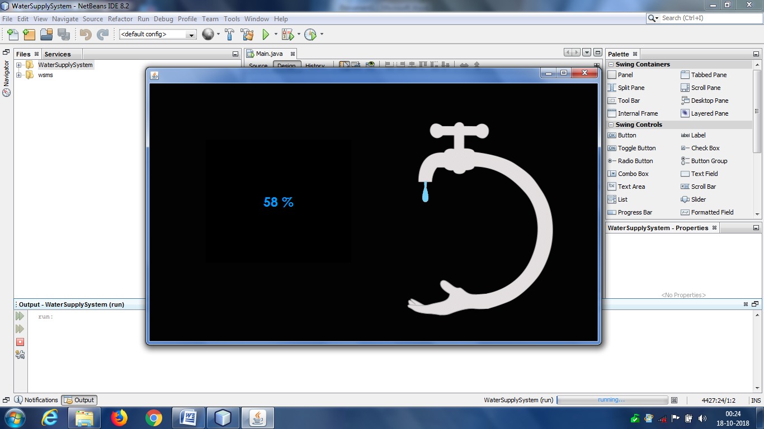

1. **Login:**

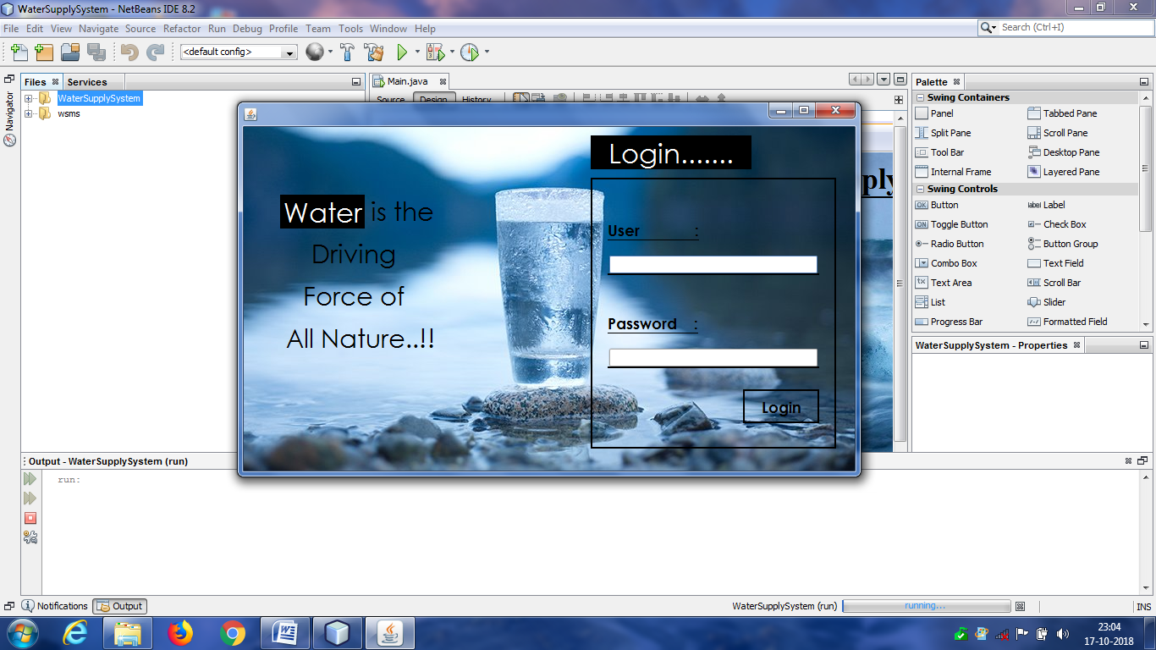

1. **Home Screen:**

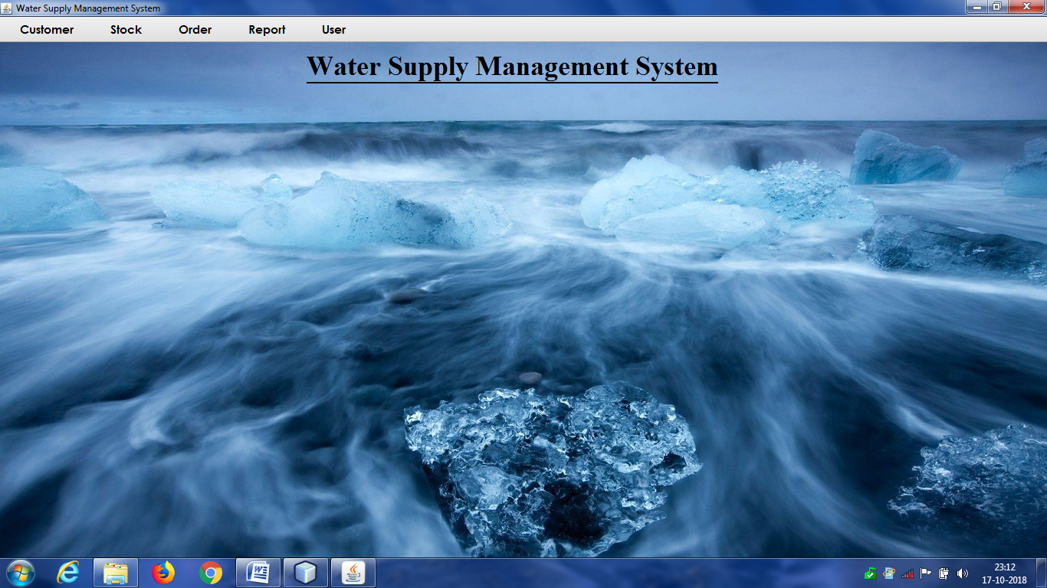

**Menus:**

a. Customer- (Add, Update, Delete, Search/View Customer)

b. Stock- (Add, Modify, Delete, Search/View Stock)

c. Order- (Order, View Order by Bill No.)

d. Report- (Customer wise, Date wise, Month wise, Year wise)

e. User- (Add Admin, Update/Delete Admin, Logout, Exit, Change Password)

1. **Add Customer:**

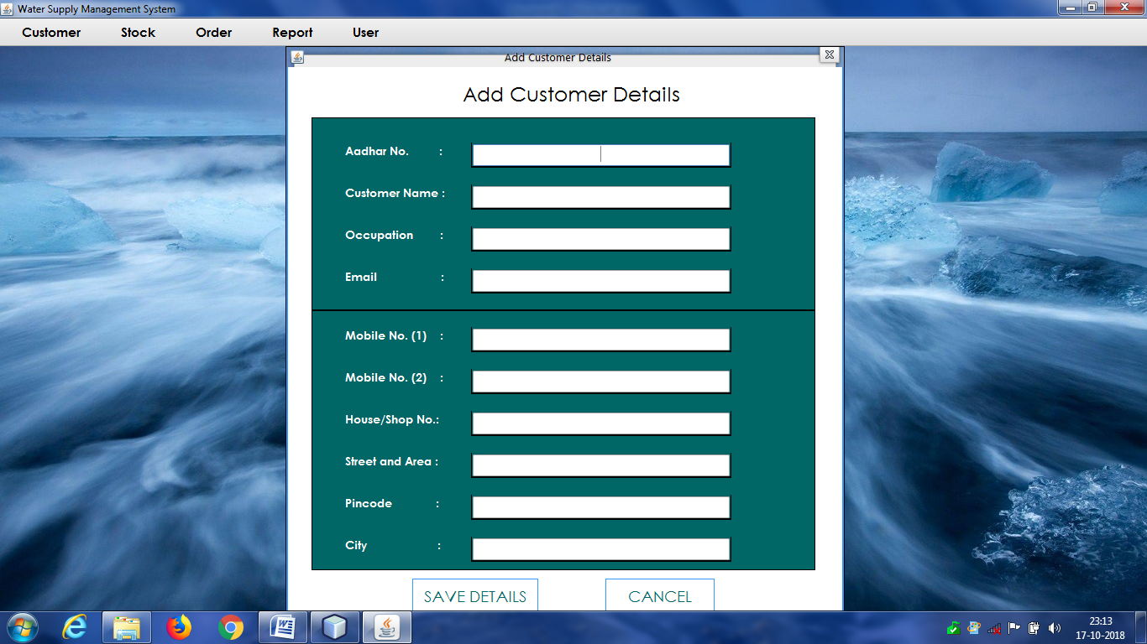

1. **Update Customer:**

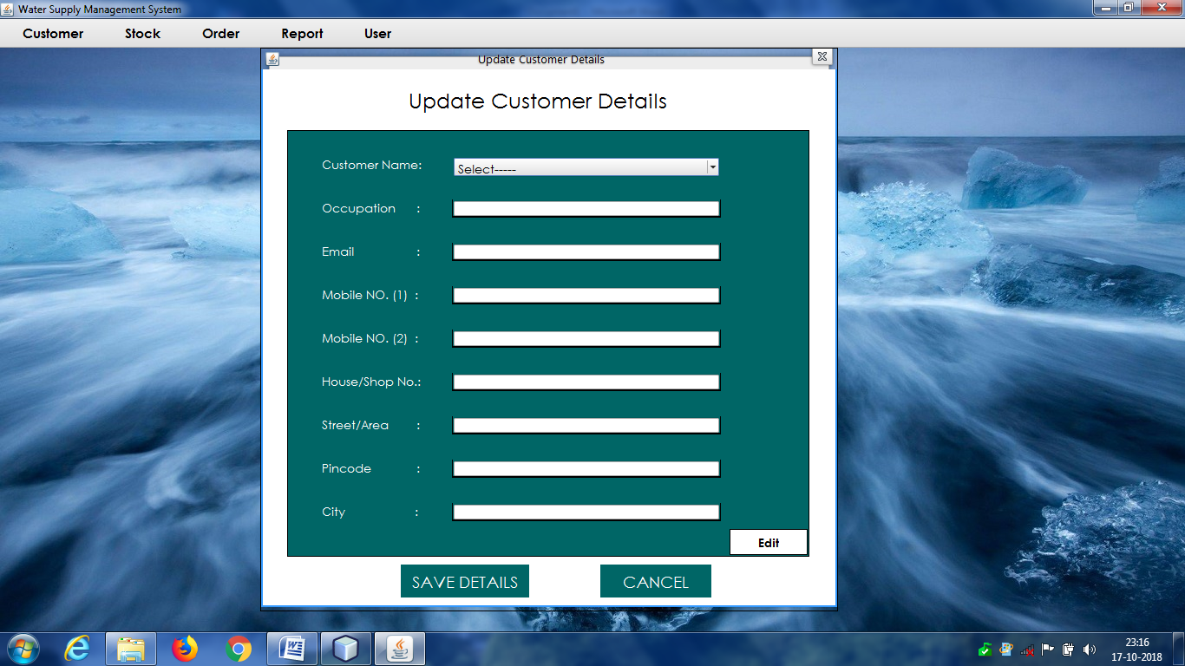

1. **Delete Customer:**

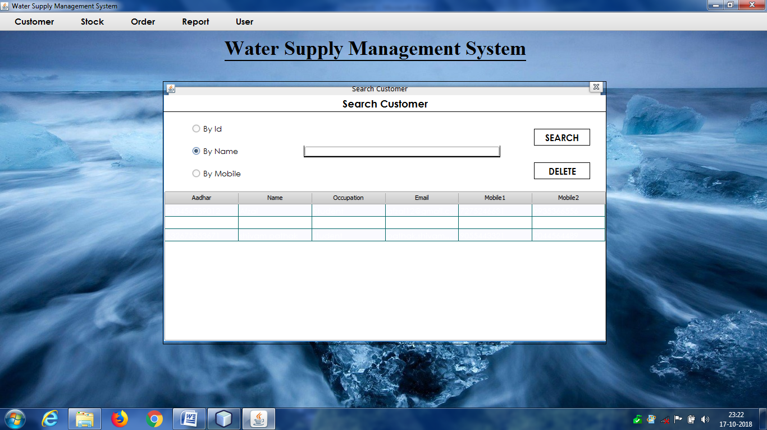

1. **Search Customer:**

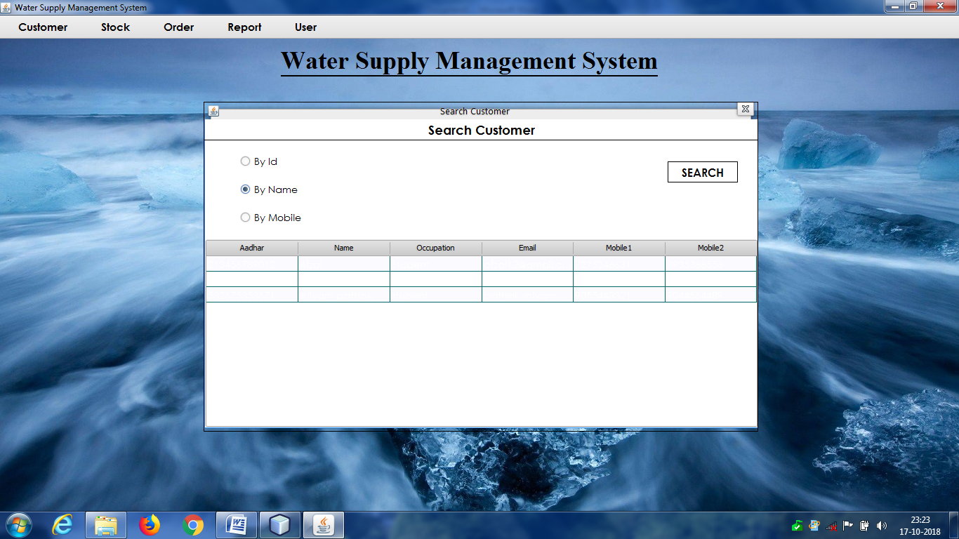

1. **Add Stock:**

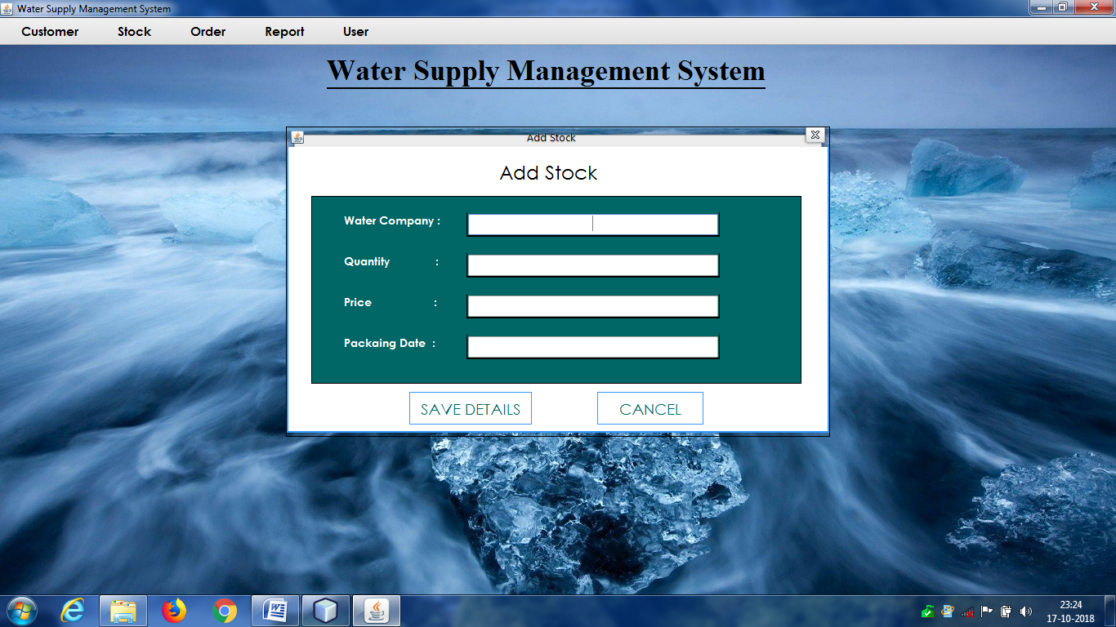

1. **Update Stock:**

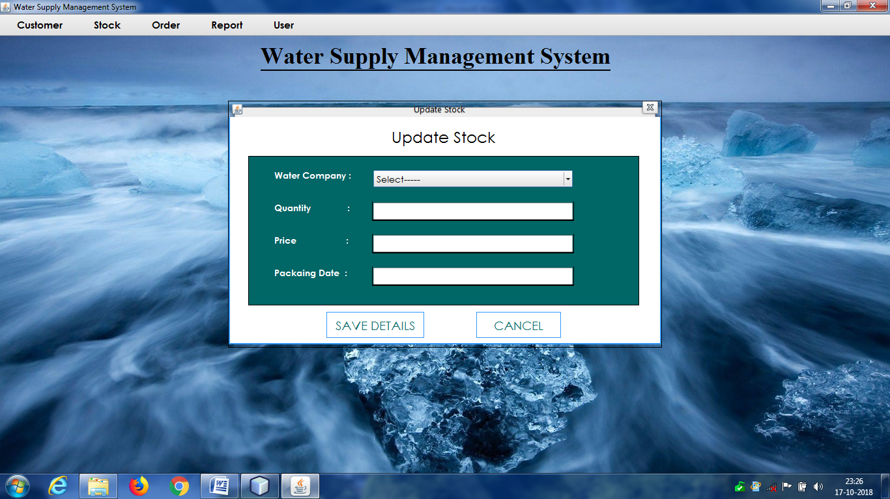

1. **Delete Stock:**

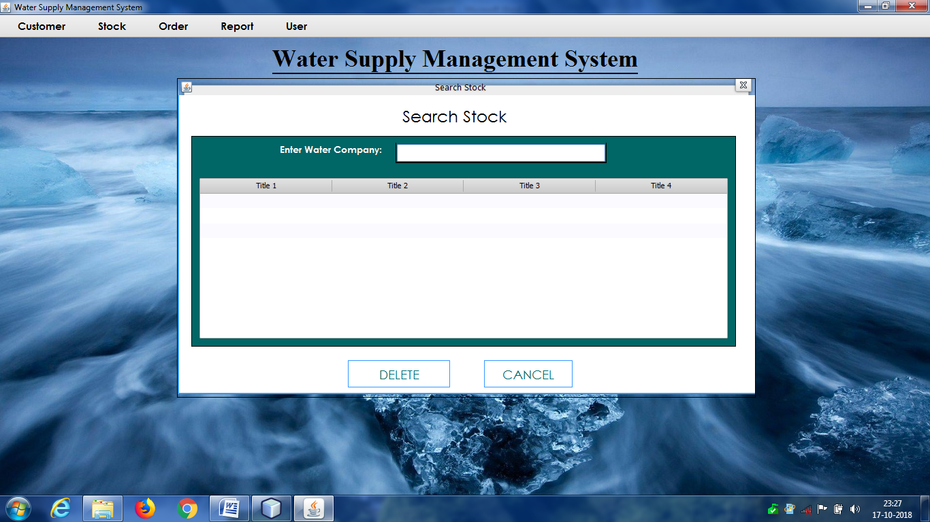

1. **Search Stock:**

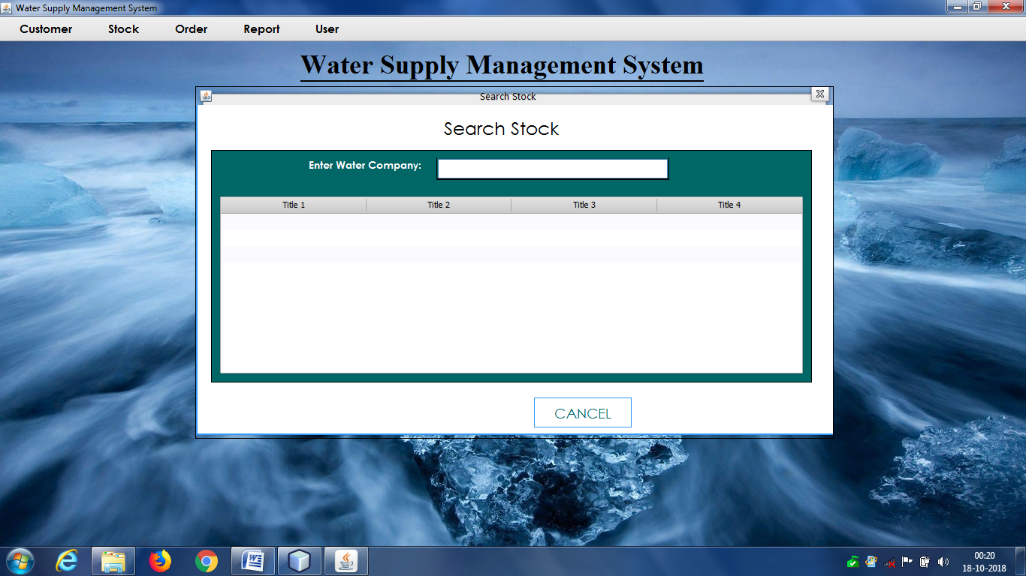

1. **Take Order:**

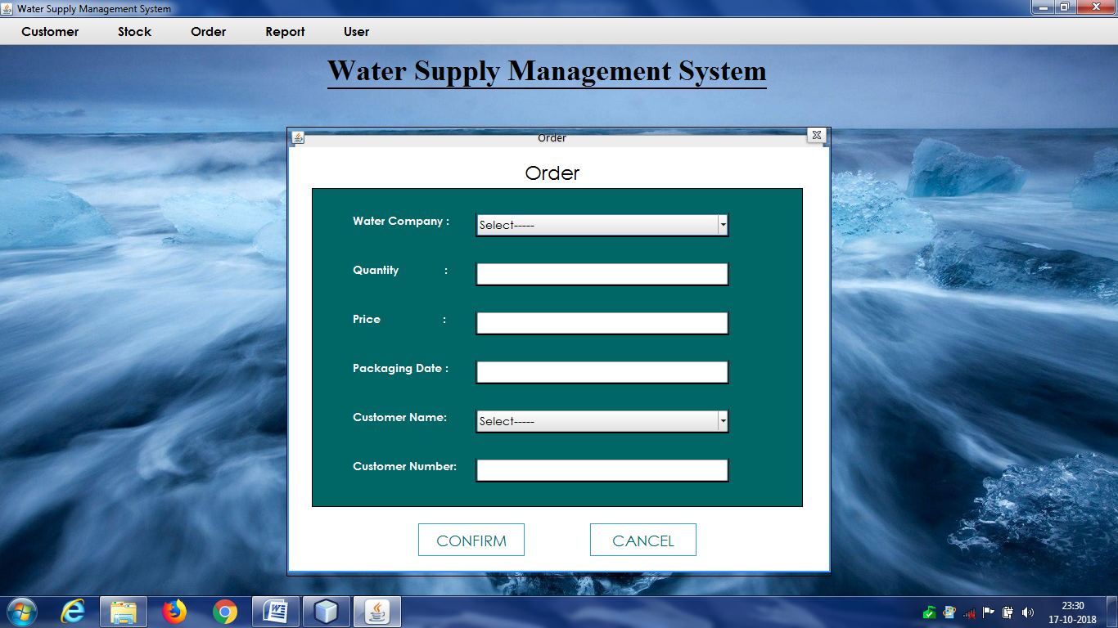

1. **Bill:**

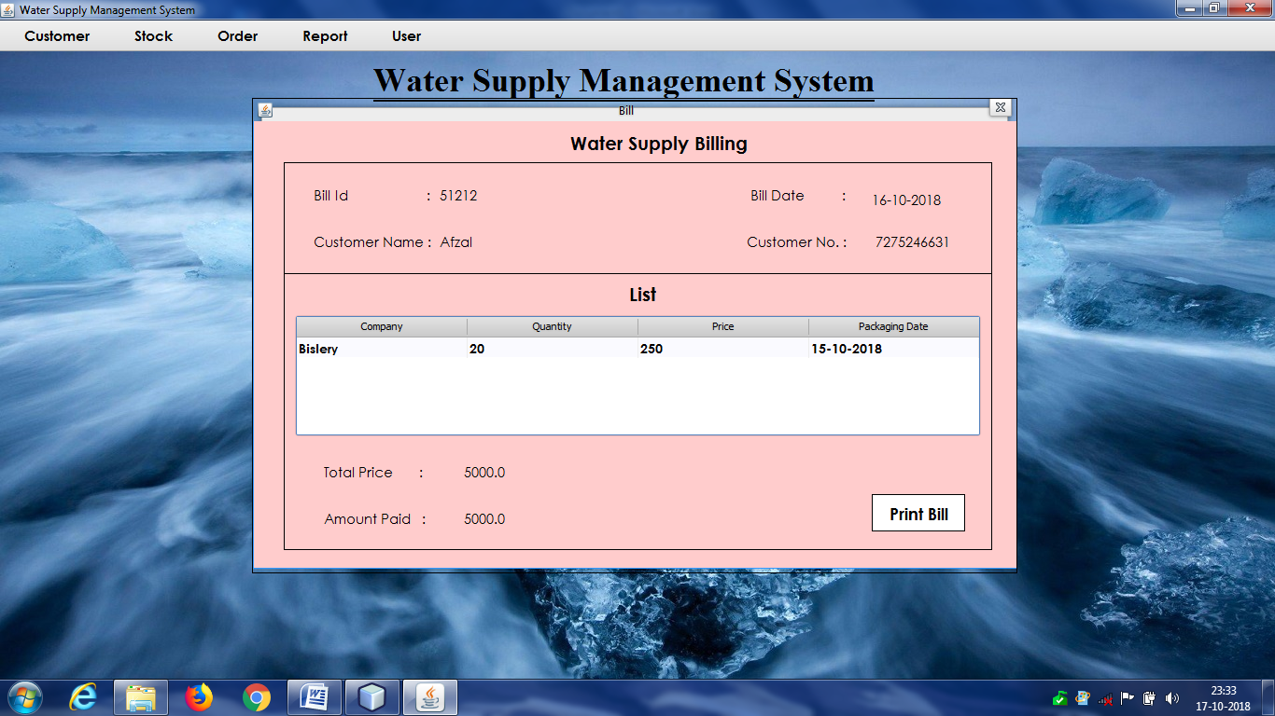

1. **View Order:**

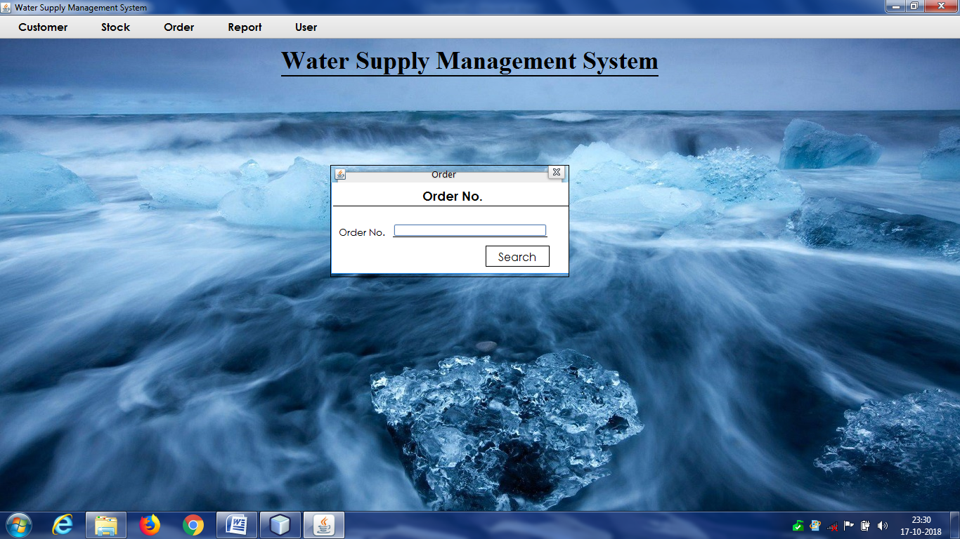

1. **Report (Customer wise):**

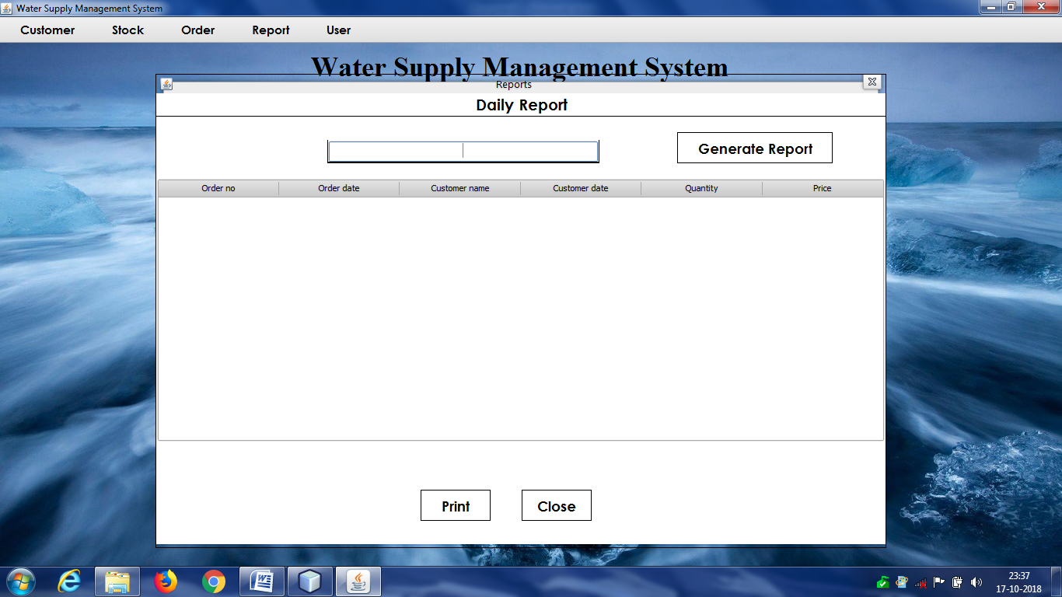

1. **Report (Date Wise):**

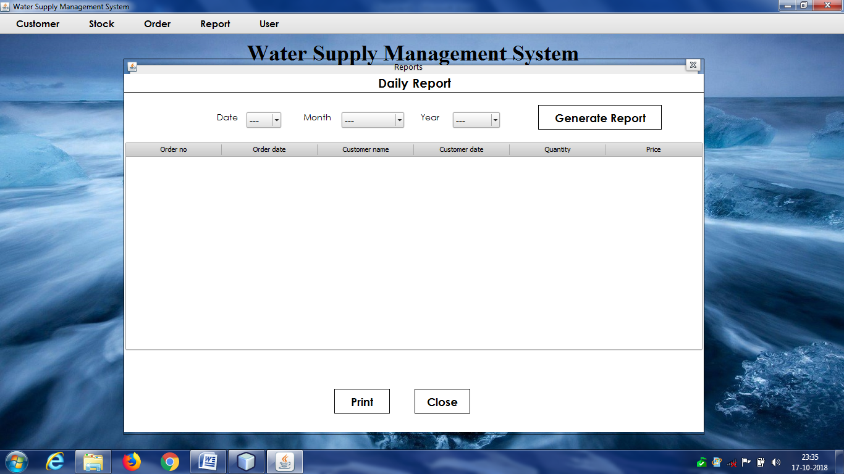

1. **Report (monthly Wise):**

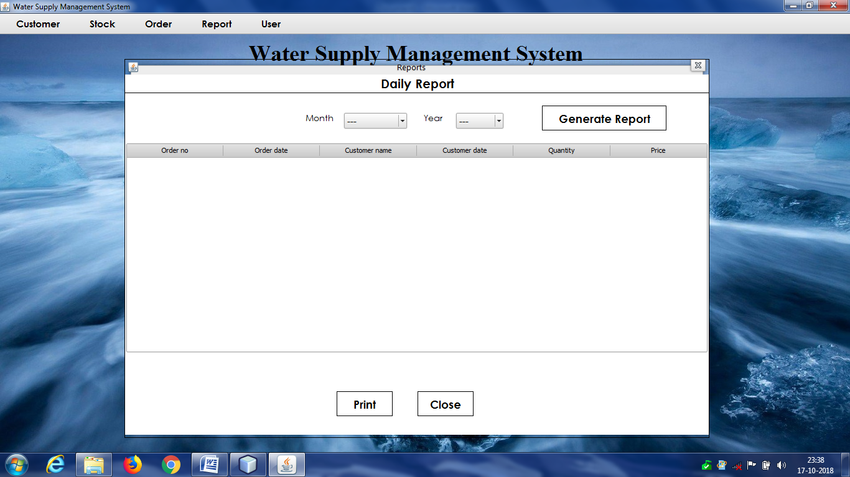

1. **Report(Yearly Wise):**

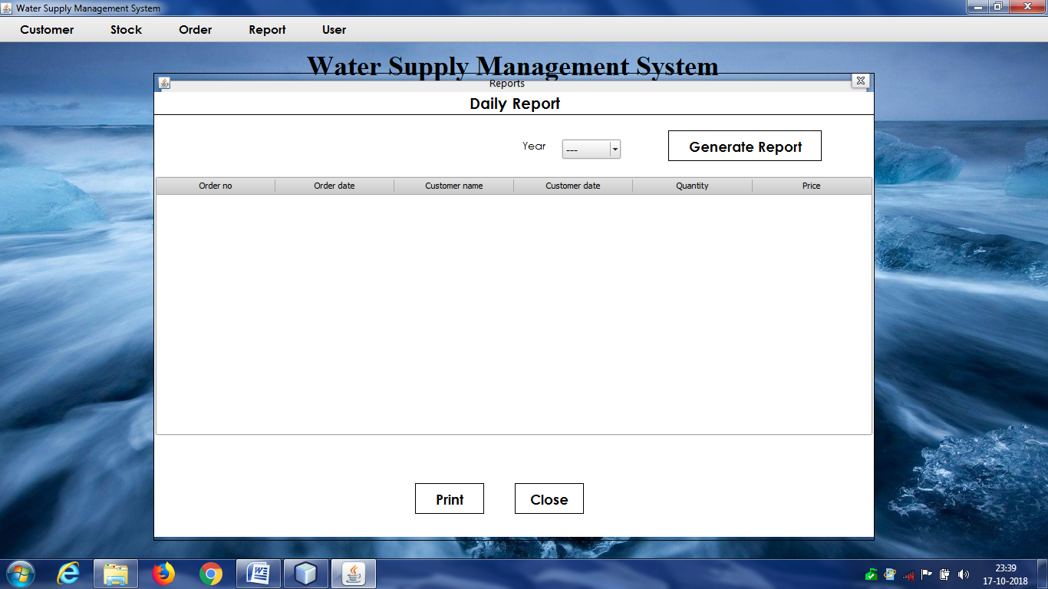

1. **Add Admin:**

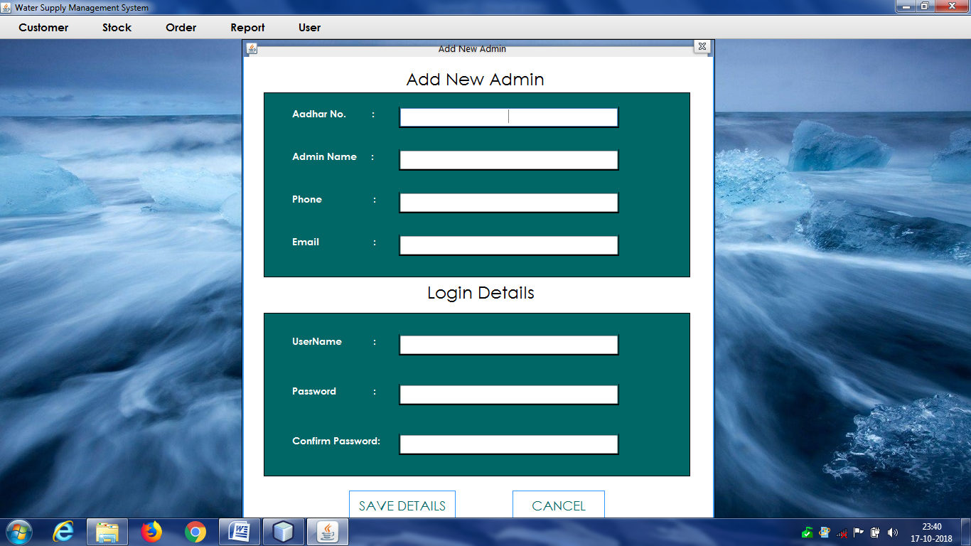

1. **Update/Delete Admin:**

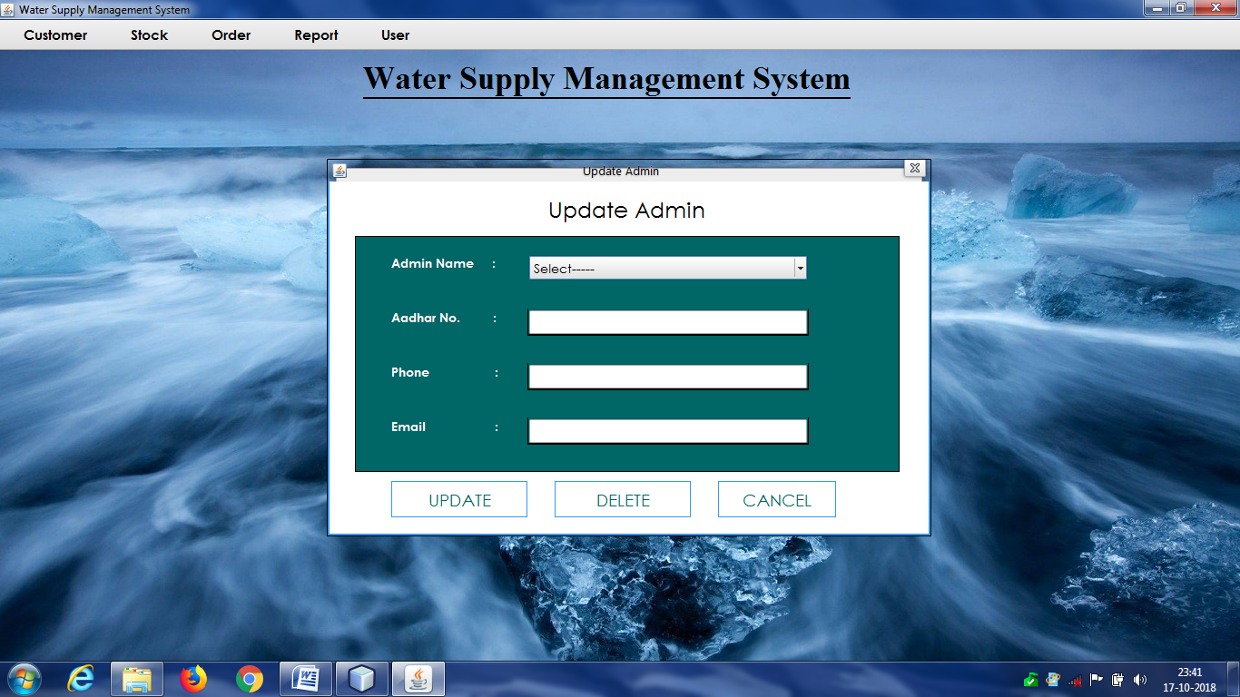

1. **Change Password:**

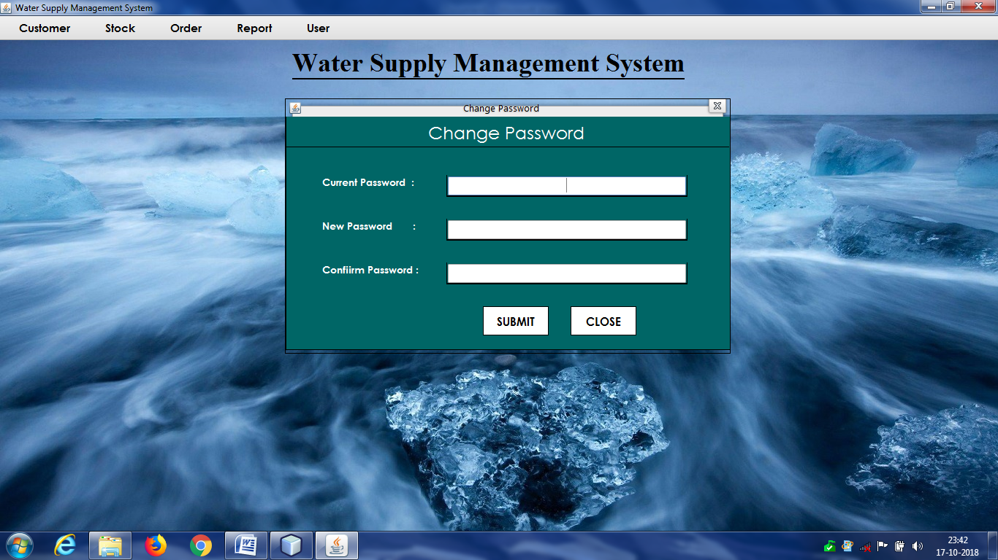

**8.2. DATA TABLES SCREENSHOTS**

1. **Customer database table:**

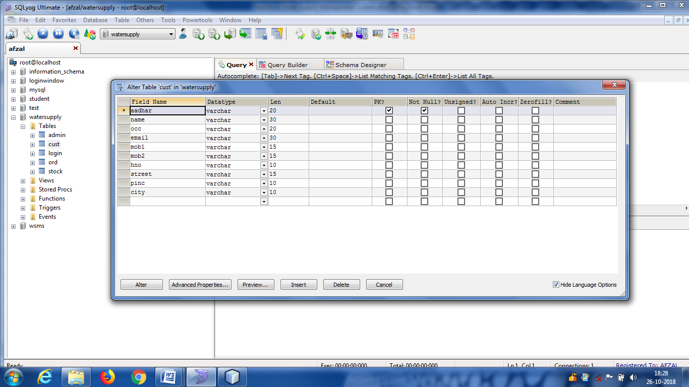

1. **Admin database table:**

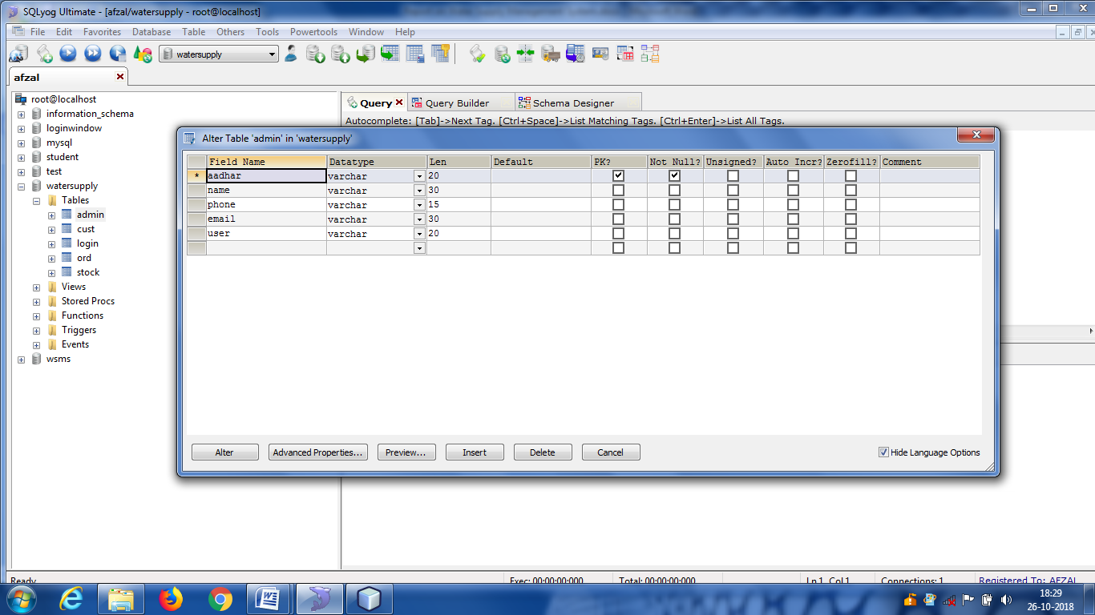

1. **Login database table:**

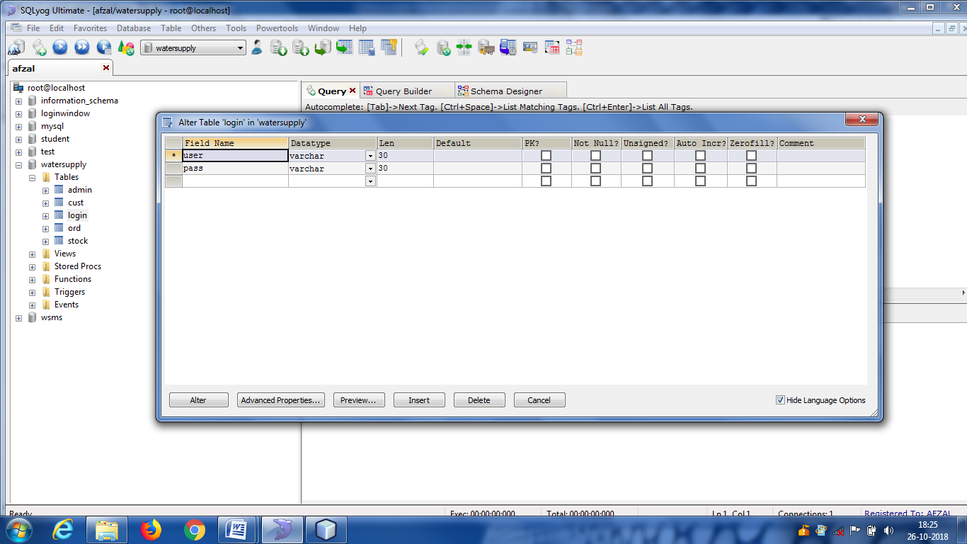

1. **Order database table:**

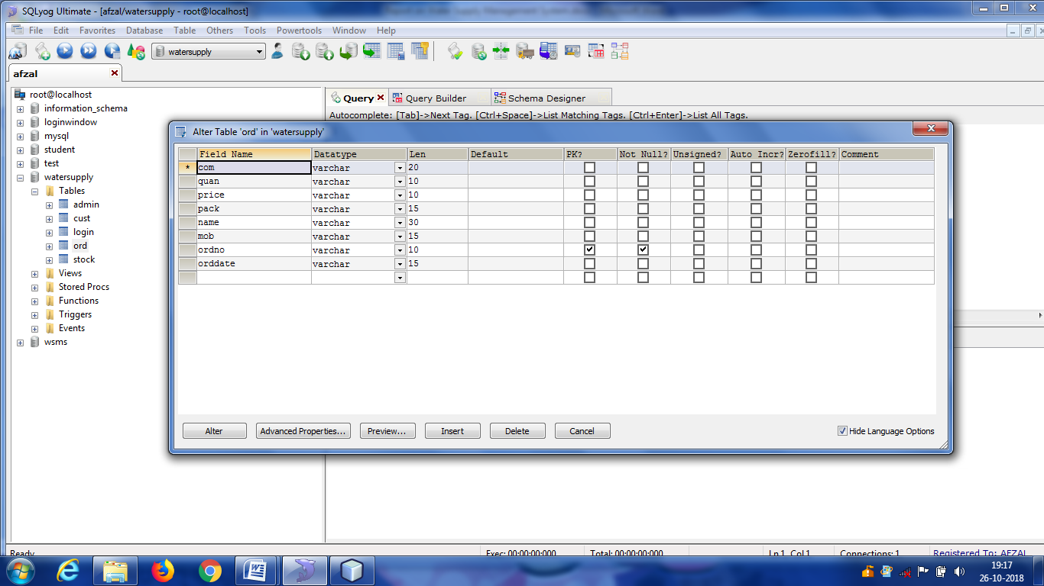

1. **Stock database table:**

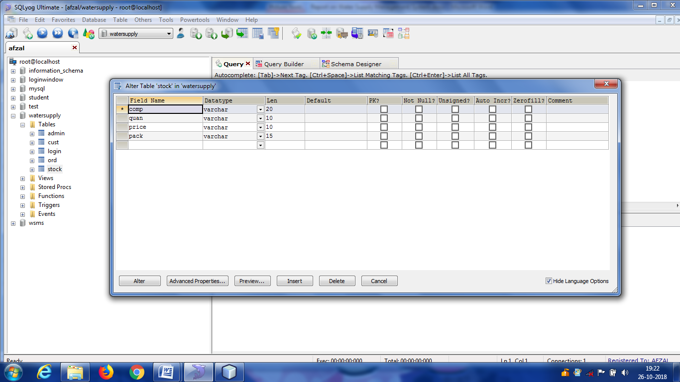

1. **IMPLEMENTATION OF SECURITY**

**System Implementation**

During the implementation stage the system in physically created. Necessary programs are coded, debugged and documented. A new hardware is selected, ordered and installed.

**System Specification**

Every computer system consists of three major elements.

1. The Hardware
2. Application software such as visual studio
3. Operating system

For successful operation of the package following must be kept in mind:

Too many packages should not be used, as very few systems may have all those packages installed due to memory problem. Thus, the compatibility of the system development will get reduced.

1. **FUTURE SCOPE OF IMPROVEMENT**

With the advent of latest technology if we do not update our system then our business result in losses gradually with time. The technical system contains the tools of latest trend i.e. computers, printers, FAX, Internet etc the system with the technology are very fast, accurate, user friendly and reliable.

The proposed system helps them in many ways. It helps users to do billing very easily. Account maintenance also becomes easier. It can keep track of their supply, amount of water and account details. The software is provided with all the master entries to enter any type of water, or supplier, or customer to add or modify and delete.

Need of AquaControl:

* To provide an optimal solution to the water supply and garbage collector supply.
* Maintaining the water supply.
* Water supply for specific period of time.
* To reduce unnecessary waste of water.
* To produce a Social Awareness About water saving Activity.

**Annexure E – Definition/Glossary**

**Data**- describe the numbers, text, graphics, images and voice stored in this form that can be used by a computer.

**Record** – A set of related data items treated as a unit.

**File-** Set of record is termed as storage of files, and record in computer

**Project Life Cycle (PLC) –** Describe a way to make a successful Project.

**Configuration status reporting (CSR) –** an activity that help software Developer to understanding what changes have been made and why.

**Prototyping-**Creating a mock –up of an application

1. **CONCLUSION**

This section discuses the result of work done in this project and also mentions the future scope improvement

The software will be developed by implementing the concept of modularity which in turn reduces the complexity involved in maintaining it. The administrator should have a sound technical knowledge about maintaining the software and further enhancements will be undertaken by the developer.

The application is portable which ensure its adaptability for use on different computer terminals with different operating system and standards.

The factors guarantee the software’s availability includes proper termination and correct input details. Also the resources used for the project development are Microsoft certified which speaks of its high quality standards.

Hence we may conclude that the application system being developed helps a great deal in modifying the computerized AQUACONTROL.

**Goal achieved:** The System is able provide the interface to the user so that he can replicate his desired data.

**User friendliness:** Though the most part of the system is supposed to act in the background, efforts have been made to make the foreground interaction with user as smooth as possible. Also the integration of the system with Water Supply Management project has been kept in mind throughout the development phase.

1. **REFERENCES**

BOOKS:-

1. Herbert Schildt, java2 complete reference, 5th edition, pregati publication, April 2000
2. Abraham Silberschatz,Henry Korth,S.Sudarshan “Database System Concept”, McGraw Hill 5th Edition 2006.
3. Rajeev Mall “Software Engineering”,TMH ,3rd Edition 1995.
4. Software engineering: a practitioners approach by Roger s Pressman.
5. System analysis and design , Elias M. Ewad.
6. DBMS , Bipin C Desai
7. Introduction to DBMS , Shailendra Sharma
8. Modern database management , Dr Kumar
9. Fundamentals of database systems , Ramez Elmsari
10. An intro to DBMS, Christhopher J Date
11. Database management systems ,Raghu Ramkrishnan
12. Principles of database systems , Jd Ullman
13. Foundation of databases ,Sergebabiteboul
14. Database systems , Connolly
15. Complete reference of java
16. Black book of java

WEBSITES:-

1. https://[www.quora.com](http://www.quora.com)
2. https://[www.geeksforgeeks.com](http://www.geeksforgeeks.com)
3. https://[www.javaskyline.com](http://www.javaskyline.com)
4. [www.youtube.com](http://www.youtube.com)
5. <https://www.tutorialspoint.com/java>
6. <http://www.javatpoint.com/java-tutorial>
7. <https://docs.oracle.com/javase/tutorial>
8. <https://www.wampserver.com/en>
9. <https://www.tutorialspoint.com/mysql>
10. <http://www.jdbc-tutorial.com>
11. [www.google.co.in](http://www.google.co.in)
12. [www.javasoft.com](http://www.javasoft.com)